20160913
# Here is how to fix troubles with stucked job in iDRAC.

# One way is to remove all jobs.
[support@centos00 20160815-1714]$ SSHPASS="$(pass common/windows-current)" sshpass -e ssh -t -oStrictHostKeyChecking=no tcsbank.ru\\s.belogrud@hg2h8d2.mgmt.tcsbank.ru racadm getsysinfo | tee -a /tmp/$(date +%Y%m%d-%H%M).getsysinfo.hg2h8d2.log

[support@centos00 20160815-1714]$ SSHPASS="$(pass common/windows-current)" sshpass -e ssh -t -oStrictHostKeyChecking=no tcsbank.ru\\s.belogrud@hg2h8d2.mgmt.tcsbank.ru racadm jobqueue delete -i JID_CLEARALL_FORCE | tee -a /tmp/$(date +%Y%m%d-%H%M).getsysinfo.hg2h8d2.log
Created Job Identifier:
RAC1032: JID_CLEARALL_FORCE job(s) was cancelled by the user.
Connection to hg2h8d2.mgmt.tcsbank.ru closed.
[support@centos00 20160815-1714]$

[support@centos00 20160815-1714]$ SSHPASS="$(pass common/windows-current)" sshpass -e ssh -t -oStrictHostKeyChecking=no tcsbank.ru\\s.belogrud@hg2h8d2.mgmt.tcsbank.ru racadm jobqueue view | tee - a /tmp/$(date +%Y%m%d-%H%M).getsysinfo.hg2h8d2.log
-------------------------JOB QUEUE------------------------
Connection to hg2h8d2.mgmt.tcsbank.ru closed.
[support@centos00 20160815-1714]$

# The second way is try to do racreset. It could be done after the first method too.
[support@centos00 20160815-1714]$ ssh -t -oStrictHostKeyChecking=no root@10.219.9.140 racadm racreset | tee -a /tmp/$(date +%Y%m%d-%H%M).getsysinfo.40zj8d2.log
root@10.219.9.140's password:
RAC reset operation initiated successfully. It may take a few
minutes for the RAC to come online again.
Connection to 10.219.9.140 closed.
[support@centos00 20160815-1714]$

20160407
# Several of useful commands for Dell servers to get some information about server.

# 20181026
[root@ds-pr-onlacq01 ~]# cat /etc/yum.repos.d/tcs-dell.repo
[tcs-dell]
gpgcheck=0
name=DLR
enabled=1
baseurl=http://repo-linux.tcsbank.ru/dell/rhel/$releasever/$basearch
[root@ds-pr-onlacq01 ~]#

[root@ds-pr-onlacq01 work]# yum install srvadmin-idracadm7

cat > $(date +%Y%m%d-%H%M).script.get.info.about.dell.server.sh

svctag="$(racadm getsvctag)" ; racadm getsysinfo | tee -a $(pwd)/$(date +%Y%m%d-%H%M).${svctag}.racadm.getsysinfo.log
svctag="$(racadm getsvctag)" ; racadm getsensorinfo | tee -a $(pwd)/$(date +%Y%m%d-%H%M).${svctag}.racadm.getsensorinfo.log
svctag="$(racadm getsvctag)" ; racadm hwinventory | tee -a $(pwd)/$(date +%Y%m%d-%H%M).${svctag}.racadm.hwinventory.log
svctag="$(racadm getsvctag)" ; racadm getraclog | tee -a $(pwd)/$(date +%Y%m%d-%H%M).${svctag}.racadm.getraclog.log
svctag="$(racadm getsvctag)" ; racadm getsel | tee -a $(pwd)/$(date +%Y%m%d-%H%M).${svctag}.racadm.getsel.log

svctag="$(racadm getsvctag)" ; omreport system summary | tee -a $(pwd)/$(date +%Y%m%d-%H%M).${svctag}.omreport.system.summary.log
svctag="$(racadm getsvctag)" ; omreport system alertlog | tee -a $(pwd)/$(date +%Y%m%d-%H%M).${svctag}.omreport.system.alertlog.log
svctag="$(racadm getsvctag)" ; omreport chassis | tee -a $(pwd)/$(date +%Y%m%d-%H%M).${svctag}.omreport.chassis.log
svctag="$(racadm getsvctag)" ; omreport chassis biossetup | tee -a $(pwd)/$(date +%Y%m%d-%H%M).${svctag}.omreport.chassis.biossetup.log

# This way helps collect all files in one directory.
[root@m1-pr-onlacq01 20181026-1952]# mkdir 20181026-1952/
[root@m1-pr-onlacq01 20181026-1952]# cd 20181026-1952/
[root@m1-pr-onlacq01 20181026-1952]# . ../20181026-1959.script.get.info.about.dell.server.sh

[root@ds-pr-onlacq01 20181026-1952]# filename="/tmp/$(date +%Y%m%d-%H%M).$(hostname).$(racadm getsvctag).hardware.info.tgz" ; tar -cvzf ${filename} ./* ; chmod 644 ${filename} ; ls -Alh ${filename}
./20181026-2001.BB76C72.racadm.getraclog.log
./20181026-2001.BB76C72.racadm.getsel.log
./20181026-2001.BB76C72.racadm.getsensorinfo.log
./20181026-2001.BB76C72.racadm.getsysinfo.log
./20181026-2001.BB76C72.racadm.hwinventory.log
./20181026-2002.BB76C72.omreport.chassis.biossetup.log
./20181026-2002.BB76C72.omreport.chassis.log
./20181026-2002.BB76C72.omreport.system.alertlog.log
./20181026-2002.BB76C72.omreport.system.summary.log
-rw-r--r-- 1 root root 23K Oct 26 20:13 /tmp/20181026-2013.ds-pr-onlacq01.BB76C72.hardware.info.tgz
[root@ds-pr-onlacq01 20181026-1952]#

[s.belogrud@TCS4357]# scp bsv@ds-pr-onlacq01:/tmp/20181026-2005.ds-pr-onlacq01.BB76C72.hardware.info.tgz /drives/c/Users/s.belogrud/Downloads/
20181026-2005.ds-pr-onlacq01.BB76C72.hardware.info.tgz 100% 22KB 22.3KB/s 00:00
[s.belogrud@TCS4357]#

# If I use only this command, I receive follow error...
[root@ds-pr-onlacq01 ~]# yum install srvadmin-idracadm

[root@ds-pr-onlacq01 work]# racadm getsvctag

NOTE:
The current version of Integrated Dell Remote Access Controller (iDRAC)
that do not support the execution of RACADM commands.
Contact Dell customer service to upgrade to iDRAC Express or iDRAC Enterprise
The installed version of RACADM client executable that do not match the
generation of the server.
[root@ds-pr-onlacq01 work]#

#
# Here is an example how I have collected and publish information about servers’s hardware and config.
# “20181026 Трудности в работе приложения на onl4acq”
https://wiki.tcsbank.ru/pages/viewpage.action?pageId=307548121&focusedCommentId=307548157&refresh=1540570275082#comment-307548157

#
# 20210301
# Get server name, service tag, iDRAC ip address.
root@ds-prod-search-es-10:~# echo -e "Server: $(hostname)" ; ipaddress="$(racadm getniccfg | egrep -e "^IP Address.*[0-9].[0-9].[0-9].[0-9]" | awk "{print \$4}")" ; servicetag="$(racadm getsvctag)" ; echo -e "$servicetag.mgmt.tcsbank.ru\t\t$ipaddress"
Server: ds-prod-search-es-10.tcsbank.ru
33JP873.mgmt.tcsbank.ru 10.219.116.7
root@ds-prod-search-es-10:~#

# 20170703
# Get server name, service tag, iDRAC ip address.
[root@m1-2-gp-prd-mdw ~]# for var1_host in m1-2-gp-prd-sdw{1..36} ; do ssh root@${var1_host} '( echo ; echo -e "Server: $(hostname)" ; ipaddress="$(racadm getniccfg | grep -e "^IP Address.*10.219.108" | awk "{print \$4}")" ; servicetag="$(racadm getsvctag)" ; echo -e "$servicetag.mgmt.tcsbank.ru\t\t$ipaddress" )' ; done
Server: m1-2-gp-prd-sdw1
D8RHXJ2.mgmt.tcsbank.ru 10.219.108.101
...

# Get name, iDRAC ip address, servicetag. Do it via sshpass.
[support@centos ~]$ list_of_hosts="" ; while read var1_hosts ; do list_of_hosts="${list_of_hosts} ${var1_hosts}" ; done << 'EOF' ; for var1_hosts in ${list_of_hosts} ; do SSHPASS="$(pass common/linux)" sshpass -e timeout 5 ssh -t -oStrictHostKeyChecking=no -oPubkeyAuthentication=no bsv@${var1_hosts}.tcsbank.ru "( echo '$(pass common/linux)' | sudo -S -i sh -c 'echo ; echo ; hostname ; /opt/dell/srvadmin/sbin/racadm getniccfg | grep -e "^IP.*Address.*=.*10.*" ; /opt/dell/srvadmin/sbin/racadm getsvctag ' )" ; done #
ds-gp-prod-sdw01
EOF

20160330
[support@centos00 ~]$ SSHPASS="$(pass common/windows-current)" sshpass -e ssh -t -oStrictHostKeyChecking=no tcsbank.ru\\s.belogrud@cblfc72.mgmt.tcsbank.ru racadm getsysinfo | tee -a /tmp/$(date +%Y%m%d-%H%M).getsysinfo.cblfc72.log

20160329
# Get service tag of Dell server.
[support@centos00 ~]$ SSHPASS="$(pass common/linux)" sshpass -e ssh -t -oStrictHostKeyChecking=no bsv@m1-hadoop-wk01t "( echo '$(pass common/linux)' | sudo -S -i sh -c ' echo ; hostname ; racadm getsvctag ' )" ; SSHPASS=''

m1-hadoop-wk01t.tcsbank.ru
1J7V762

Connection to m1-hadoop-wk01t closed.
[support@centos00 ~]$

2015XXXX

[root@vm-vol-nag01t ~]# rpm -qf /usr/lib64/nagios/plugins/check_openmanage
nagios-plugins-openmanage-3.7.12-1.el6.x86_64
[root@vm-vol-nag01t ~]# rpm -q nagios-plugins-openmanage
nagios-plugins-openmanage-3.7.12-1.el6.x86_64
[root@vm-vol-nag01t ~]# rpm -qi nagios-plugins-openmanage
Name : nagios-plugins-openmanage Relocations: (not relocatable)
Version : 3.7.12 Vendor: Fedora Project
Release : 1.el6 Build Date: Mon 28 Jul 2014 07:20:48 PM MSK
Install Date: Wed 05 Aug 2015 04:06:18 PM MSK Build Host: buildhw-06.phx2.fedoraproject.org
Group : Applications/System Source RPM: nagios-plugins-openmanage-3.7.12-1.el6.src.rpm
Size : 279140 License: GPLv3+
Signature : RSA/8, Tue 29 Jul 2014 09:50:39 PM MSK, Key ID 3b49df2a0608b895
Packager : Fedora Project
URL : http://folk.uio.no/trondham/software/check_openmanage.html
Summary : Nagios plugin to monitor hardware health on Dell servers
Description :
check_openmanage is a plugin for Nagios which checks the hardware
health of Dell servers running OpenManage Server Administrator
(OMSA). The plugin can be used remotely with SNMP or locally with
NRPE, check_by_ssh or similar, whichever suits your needs and
particular taste. The plugin checks the health of the storage
subsystem, power supplies, memory modules, temperature probes etc.,
and gives an alert if any of the components are faulty or operate
outside normal parameters.
[root@vm-vol-nag01t ~]#

# Nice way to get usefull and brief information.
[root@vm-vol-nag01t nagios]# /usr/lib64/nagios/plugins/check_openmanage -H m1-hadoop-wk01t -C tcspub -P 1 -p -d
System: PowerEdge R730xd OMSA version: 8.1.0
ServiceTag: 1J7V762 Plugin version: 3.7.12
BIOS/date: 1.3.6 06/03/2015 Checking mode: SNMPv1 UDP/IPv4
-----------------------------------------------------------------------------
Storage Components
=============================================================================
STATE | ID | MESSAGE TEXT
---------+----------+--------------------------------------------------------
OK | 0 | Controller 0 [PERC H730P Mini] is Ready
OK | 0:0:1:0 | Physical Disk 0:1:0 [SAS-HDD 4.0TB] on ctrl 0 is Non-RAID
OK | 0:0:1:1 | Physical Disk 0:1:1 [SAS-HDD 4.0TB] on ctrl 0 is Non-RAID
OK | 0:0:1:2 | Physical Disk 0:1:2 [SAS-HDD 4.0TB] on ctrl 0 is Non-RAID
OK | 0:0:1:3 | Physical Disk 0:1:3 [SAS-HDD 4.0TB] on ctrl 0 is Non-RAID
OK | 0:0:1:4 | Physical Disk 0:1:4 [SAS-HDD 4.0TB] on ctrl 0 is Non-RAID
OK | 0:0:1:5 | Physical Disk 0:1:5 [SAS-HDD 4.0TB] on ctrl 0 is Non-RAID
OK | 0:0:1:6 | Physical Disk 0:1:6 [SAS-HDD 4.0TB] on ctrl 0 is Non-RAID
OK | 0:0:1:7 | Physical Disk 0:1:7 [SAS-HDD 4.0TB] on ctrl 0 is Non-RAID
OK | 0:0:1:8 | Physical Disk 0:1:8 [SAS-HDD 4.0TB] on ctrl 0 is Non-RAID
OK | 0:0:1:9 | Physical Disk 0:1:9 [SAS-HDD 4.0TB] on ctrl 0 is Non-RAID
OK | 0:0:1:10 | Physical Disk 0:1:10 [SAS-HDD 4.0TB] on ctrl 0 is Non-RAID
OK | 0:0:1:11 | Physical Disk 0:1:11 [SAS-HDD 4.0TB] on ctrl 0 is Non-RAID
OK | 0:0:1:12 | Physical Disk 0:1:12 [SAS-HDD 500GB] on ctrl 0 is Online
OK | 0:0:1:13 | Physical Disk 0:1:13 [SAS-HDD 500GB] on ctrl 0 is Online
OK | 0:0 | Logical Drive '/dev/sdm' [RAID-1, 465.25 GB] is Ready
OK | 0:0 | Cache Battery 0 in controller 0 is Ready
OK | 0:0 | Connector 0 [SAS] on controller 0 is Ready
OK | 0:0:1 | Enclosure 0:0:1 [Backplane] on controller 0 is Ready
-----------------------------------------------------------------------------
Chassis Components
=============================================================================
STATE | ID | MESSAGE TEXT
---------+------+------------------------------------------------------------
OK | 0 | Memory module 0 [A1, 16384 MB] is Ok
OK | 1 | Memory module 1 [A2, 16384 MB] is Ok
OK | 2 | Memory module 2 [A3, 16384 MB] is Ok
OK | 3 | Memory module 3 [A4, 16384 MB] is Ok
OK | 4 | Memory module 4 [A5, 16384 MB] is Ok
OK | 5 | Memory module 5 [A6, 16384 MB] is Ok
OK | 6 | Memory module 6 [A7, 16384 MB] is Ok
OK | 7 | Memory module 7 [A8, 16384 MB] is Ok
OK | 8 | Memory module 8 [B1, 16384 MB] is Ok
OK | 9 | Memory module 9 [B2, 16384 MB] is Ok
OK | 10 | Memory module 10 [B3, 16384 MB] is Ok
OK | 11 | Memory module 11 [B4, 16384 MB] is Ok
OK | 12 | Memory module 12 [B5, 16384 MB] is Ok
OK | 13 | Memory module 13 [B6, 16384 MB] is Ok
OK | 14 | Memory module 14 [B7, 16384 MB] is Ok
OK | 15 | Memory module 15 [B8, 16384 MB] is Ok
OK | 0 | Chassis fan 0 [System Board Fan1 RPM] reading: 6840 RPM
OK | 1 | Chassis fan 1 [System Board Fan2 RPM] reading: 6840 RPM
OK | 2 | Chassis fan 2 [System Board Fan3 RPM] reading: 6960 RPM
OK | 3 | Chassis fan 3 [System Board Fan4 RPM] reading: 6480 RPM
OK | 4 | Chassis fan 4 [System Board Fan5 RPM] reading: 7200 RPM
OK | 5 | Chassis fan 5 [System Board Fan6 RPM] reading: 6600 RPM
OK | 0 | Power Supply 0 [AC]: Presence detected
OK | 1 | Power Supply 1 [AC]: Presence detected
OK | 0 | Temperature Probe 0 [System Board Inlet Temp] reads 24 C (min=3/-7, max=42/47)
OK | 1 | Temperature Probe 1 [System Board Exhaust Temp] reads 48 C (max=70/75)
OK | 2 | Temperature Probe 2 [CPU1 Temp] reads 62 C (min=8/3, max=82/87)
OK | 3 | Temperature Probe 3 [CPU2 Temp] reads 65 C (min=8/3, max=82/87)
OK | 0 | Processor 0 [Intel Xeon E5-2640 v3 2.60GHz] is Present
OK | 1 | Processor 1 [Intel Xeon E5-2640 v3 2.60GHz] is Present
OK | 0 | Voltage sensor 0 [CPU1 VCORE PG] is Good
OK | 1 | Voltage sensor 1 [CPU2 VCORE PG] is Good
OK | 2 | Voltage sensor 2 [System Board 3.3V PG] is Good
OK | 3 | Voltage sensor 3 [System Board 5V AUX PG] is Good
OK | 4 | Voltage sensor 4 [CPU2 M23 VPP PG] is Good
OK | 5 | Voltage sensor 5 [CPU1 M23 VPP PG] is Good
OK | 6 | Voltage sensor 6 [System Board 1.05V PG] is Good
OK | 7 | Voltage sensor 7 [System Board BP0 5V PG] is Good
OK | 8 | Voltage sensor 8 [CPU1 M23 VDDQ PG] is Good
OK | 9 | Voltage sensor 9 [CPU1 M23 VTT PG] is Good
OK | 10 | Voltage sensor 10 [System Board 5V SWITCH PG] is Good
OK | 11 | Voltage sensor 11 [System Board DIMM PG] is Good
OK | 12 | Voltage sensor 12 [System Board VCCIO PG] is Good
OK | 13 | Voltage sensor 13 [CPU2 M01 VDDQ PG] is Good
OK | 14 | Voltage sensor 14 [CPU1 M01 VDDQ PG] is Good
OK | 15 | Voltage sensor 15 [CPU2 M23 VTT PG] is Good
OK | 16 | Voltage sensor 16 [CPU2 M01 VTT PG] is Good
OK | 17 | Voltage sensor 17 [System Board NDC PG] is Good
OK | 18 | Voltage sensor 18 [CPU2 M01 VPP PG] is Good
OK | 19 | Voltage sensor 19 [CPU1 M01 VPP PG] is Good
OK | 20 | Voltage sensor 20 [CPU2 M23 VDDQ PG] is Good
OK | 21 | Voltage sensor 21 [System Board 1.5V PG] is Good
OK | 22 | Voltage sensor 22 [PS2 PG Fail] is Good
OK | 23 | Voltage sensor 23 [System Board PS1 PG Fail] is Good
OK | 24 | Voltage sensor 24 [System Board BP1 5V PG] is Good
OK | 25 | Voltage sensor 25 [System Board 1.5V AUX PG] is Good
OK | 26 | Voltage sensor 26 [CPU1 M01 VTT PG] is Good
OK | 27 | Voltage sensor 27 [PS1 Voltage 1] reads 230 V
OK | 28 | Voltage sensor 28 [PS2 Voltage 2] reads 230 V
OK | 29 | Voltage sensor 29 [CPU1 FIVR PG] is Good
OK | 30 | Voltage sensor 30 [CPU2 FIVR PG] is Good
OK | 31 | Voltage sensor 31 [System Board 2.5V AUX PG] is Good
OK | 0 | Battery probe 0 [System Board CMOS Battery] is Presence Detected
OK | 0 | Amperage probe 0 [PS1 Current 1] reads 1.4 A
OK | 1 | Amperage probe 1 [PS2 Current 2] reads 0.2 A
OK | 2 | Amperage probe 2 [System Board Pwr Consumption] reads 322 W
OK | 0 | Chassis intrusion 0 detection: Ok (Not Breached)
OK | 0 | SD Card 0 [vFlash] is Absent
-----------------------------------------------------------------------------
Other messages
=============================================================================
STATE | MESSAGE TEXT
---------+-------------------------------------------------------------------
OK | ESM log health is Ok (less than 80% full)
OK | Chassis Service Tag is sane
[root@vm-vol-nag01t nagios]#

# To print only storage configuration.
[root@vm-vol-nag4-tst etc]# for var1 in {1..36} ; do echo ; echo m1-2-gp-prd-sdw${var1} ; /usr/lib64/nagios/plugins/check_openmanage -H m1-2-gp-prd-sdw${var1} -C tcspub -P 1 -p -d | sed -n "/Storage Components/,/Chassis Components/p" ; done
...
m1-2-gp-prd-sdw36
Storage Components
=============================================================================
STATE | ID | MESSAGE TEXT
---------+----------+--------------------------------------------------------
OK | 0 | Controller 0 [PERC H730P Mini] is Ready
OK | 1 | Controller 1 [PERC H730P Adapter] is Ready
OK | 0:0:1:1 | Physical Disk 0:1:1 [SAS-HDD 600GB] on ctrl 0 is Online
OK | 0:0:1:2 | Physical Disk 0:1:2 [SAS-HDD 600GB] on ctrl 0 is Online
OK | 0:0:1:3 | Physical Disk 0:1:3 [SAS-HDD 600GB] on ctrl 0 is Online
OK | 0:0:1:4 | Physical Disk 0:1:4 [SAS-HDD 600GB] on ctrl 0 is Online
OK | 0:0:1:5 | Physical Disk 0:1:5 [SAS-HDD 600GB] on ctrl 0 is Online
OK | 0:0:1:6 | Physical Disk 0:1:6 [SAS-HDD 600GB] on ctrl 0 is Online
OK | 0:0:1:7 | Physical Disk 0:1:7 [SAS-HDD 600GB] on ctrl 0 is Online
OK | 0:0:1:8 | Physical Disk 0:1:8 [SAS-HDD 600GB] on ctrl 0 is Online
OK | 0:0:1:9 | Physical Disk 0:1:9 [SAS-HDD 600GB] on ctrl 0 is Ready (Global HS)
OK | 1:0:1:12 | Physical Disk 0:1:12 [SAS-SSD 480GB] on ctrl 1 is Non-RAID
OK | 1:0:1:13 | Physical Disk 0:1:13 [SAS-HDD 600GB] on ctrl 1 is Online
OK | 1:0:1:14 | Physical Disk 0:1:14 [SAS-HDD 600GB] on ctrl 1 is Online
OK | 1:0:1:15 | Physical Disk 0:1:15 [SAS-HDD 600GB] on ctrl 1 is Online
OK | 1:0:1:16 | Physical Disk 0:1:16 [SAS-HDD 600GB] on ctrl 1 is Online
OK | 1:0:1:17 | Physical Disk 0:1:17 [SAS-HDD 600GB] on ctrl 1 is Online
OK | 1:0:1:18 | Physical Disk 0:1:18 [SAS-HDD 600GB] on ctrl 1 is Online
OK | 1:0:1:19 | Physical Disk 0:1:19 [SAS-HDD 600GB] on ctrl 1 is Online
OK | 1:0:1:20 | Physical Disk 0:1:20 [SAS-HDD 600GB] on ctrl 1 is Online
OK | 1:0:1:21 | Physical Disk 0:1:21 [SAS-SSD 480GB] on ctrl 1 is Ready
WARNING | 0:0:1:0 | Physical Disk 0:1:0 [Dell AL14SEB060N, 600GB] on ctrl 0 is Foreign
OK | 0:0 | Logical Drive '/dev/sdb' [RAID-1, 558.38 GB] is Ready
OK | 0:1 | Logical Drive '/dev/sdc' [RAID-10, 1675.12 GB] is Ready
OK | 1:0 | Logical Drive '/dev/sde' [RAID-10, 2233.50 GB] is Ready
OK | 0:0 | Cache Battery 0 in controller 0 is Ready
OK | 1:0 | Cache Battery 0 in controller 1 is Ready
OK | 0:0 | Connector 0 [SAS] on controller 0 is Ready
OK | 1:0 | Connector 0 [SAS] on controller 1 is Ready
OK | 0:0:1 | Enclosure 0:0:1 [Backplane] on controller 0 is Ready
OK | 1:0:1 | Enclosure 1:0:1 [Backplane] on controller 1 is Ready
-----------------------------------------------------------------------------
Chassis Components
[root@vm-vol-nag4-tst etc]#

# Same as above, olnly with selection of two HDD.
[root@vm-vol-nag4-tst etc]# for var1 in {1..36} ; do echo ; echo m1-2-gp-prd-sdw${var1} ; /usr/lib64/nagios/plugins/check_openmanage -H m1-2-gp-prd-sdw${var1} -C tcspub -P 1 -p -d | sed -n "/Storage Components/,/Chassis Components/p" | egrep -e "0:0:1:0|1:0:1:21" ; done

# To get information about properly configured power supply on server.
[support@centos00 ~]$ SSHPASS="$(pass common/windows-current)" sshpass -e ssh -t -oStrictHostKeyChecking=no tcsbank.ru\\s.belogrud@cblfc72.mgmt.tcsbank.ru racadm get system.power.HotSpare.Enable
Warning: Permanently added 'cblfc72.mgmt.tcsbank.ru,10.219.10.234' (RSA) to the list of known hosts.
Disabled
Connection to cblfc72.mgmt.tcsbank.ru closed.
[support@centos00 ~]$ SSHPASS="$(pass common/windows-current)" sshpass -e ssh -t -oStrictHostKeyChecking=no tcsbank.ru\\s.belogrud@cblfc72.mgmt.tcsbank.ru racadm get system.power.RedundancyPolicy
Input Power Redundant
Connection to cblfc72.mgmt.tcsbank.ru closed.
[support@centos00 ~]$

# Here is a way how to set this parameter to properly value.
[support@centos00 20160315-1129]$ SSHPASS="$(pass common/windows-current)" sshpass -e ssh -t -oStrictHostKeyChecking=no tcsbank.ru\\s.belogrud@bb5bc72.mgmt.tcsbank.ru racadm set system.power.HotSpare.Enable Disabled
Object value modified successfully
Connection to bb5bc72.mgmt.tcsbank.ru closed.
[support@centos00 20160315-1129]$

20160406
# Get details about hardware.
[support@centos00 ~]$ SSHPASS="$(pass common/windows-current)" sshpass -e ssh -t -oStrictHostKeyChecking=no -oPubkeyAuthentication=no tcsbank.ru\\s.belogrud@HS6V762.mgmt.tcsbank.ru racadm hwinventory | tee -a /home/support/mnt/share/temp/$(date +%Y%m%d-%H%M).HS6V762.hwinventory.txt ; SSHPASS=''
-------------------------HARDWARE INVENTORY------------------------

[InstanceID: CPU.Socket.1]
Device Type = CPU
Cache3Location = 0
Cache2Location = 0
Cache1Location = 0
Model = Intel(R) Xeon(R) CPU E5-2640 v3 @ 2.60GHz
Manufacturer = Intel
TurboModeCapable = 1
TurboModeEnabled = 1
ExecuteDisabledCapable = 1
ExecuteDisabledEnabled = 1
VirtualizationTechnologyCapable = 1
VirtualizationTechnologyEnabled = 1
HyperThreadingCapable = 1
HyperThreadingEnabled = 1
NumberOfProcessorCores = 8
NumberOfEnabledThreads = 16
...
-------------------------------------------------------------------

[InstanceID: iDRAC.Embedded.1-1#IDRACinfo]
Device Type = iDRACCard
DNSDomainName = tcsbank.ru
DNSRacName = idrac-HS6V762
URLString = https://10.219.11.66:443
GUID = 3236374f-c0c8-5680-3610-00534c4c4544
PermanentMACAddress = 44:a8:42:35:f5:0e
ProductDescription = This system component provides a complete set of remote management functions for Dell PowerEdge servers
Model = Enterprise
FirmwareVersion = 2.21.21.21
IPMIVersion = 2.0
DeviceDescription = iDRAC
FQDD = iDRAC.Embedded.1-1
InstanceID = iDRAC.Embedded.1-1#IDRACinfo
LastSystemInventoryTime = 2016-04-04T15:52:16
LastUpdateTime = 2016-04-06T15:15:42
LANEnabledState = Enabled
SOLEnabledState = Enabled
-------------------------------------------------------------------

Connection to HS6V762.mgmt.tcsbank.ru closed.
[support@centos00 ~]$

# Some info about firmware verison could be found there.
[support@centos00 ~]$ grep -i -e firmware /home/support/mnt/share/temp/20160406-1815.HS6V762.hwinventory.txt
ControllerFirmwareVersion = 25.3.0.0016
FirmwareVersion = 00.10.37
FirmwareVersion = 00.10.37
FirmwareVersion = 2.21.21.21
[support@centos00 ~]$

20160323
#
# Clear ESM log can be done with CLI racadm utility.
#
[support@centos00 20160315-1129]$ ssh tcsbank.ru\\s.belogrud@CBLFC72.mgmt.tcbank.ru
ssh: Could not resolve hostname CBLFC72.mgmt.tcbank.ru: Name or service not known
[support@centos00 20160315-1129]$ ssh tcsbank\\s.belogrud@cblfc72.mgmt.tcsbank.ru
The authenticity of host 'cblfc72.mgmt.tcsbank.ru (10.219.10.234)' can't be established.
RSA key fingerprint is 95:cd:08:ca:fe:3b:ca:88:b3:25:7f:d4:37:5a:0e:60.
Are you sure you want to continue connecting (yes/no)? yes
Warning: Permanently added 'cblfc72.mgmt.tcsbank.ru,10.219.10.234' (RSA) to the list of known hosts.
tcsbank\s.belogrud@cblfc72.mgmt.tcsbank.ru's password: ****

# To be sure that we connect to right server.

/admin1-> racadm getsysinfo
...
Host Name = DS-AIC-VOICE16
OS Name = Microsoft Windows Server 2012 R2, Standard x64 Edition
...
/admin1-> racadm
racadm>>help
...
clrsel -- clear the System Event Log (SEL)
...

racadm>>clrsel

racadm clrsel
The SEL was cleared successfully

racadm>>quit
/admin1-> exit
CLP Session terminated
Connection to cblfc72.mgmt.tcsbank.ru closed.
[support@centos00 20160315-1129]$

# How to get “ESM” log or same, just with other name “SEL” log (System Event Log)
[support@centos00 ~]$ ssh tcsbank.ru\\s.belogrud@cblfc72.mgmt.tcsbank.ru racadm getsel
tcsbank.ru\s.belogrud@cblfc72.mgmt.tcsbank.ru's password:
Record: 1
Date/Time: 03/23/2016 18:39:54
Source: system
Severity: Ok
Description: Log cleared.
-------------------------------------------------------------------------------
Record: 2
Date/Time: 03/23/2016 18:41:07
Source: system
Severity: Non-Critical
Description: The system board battery is low.
-------------------------------------------------------------------------------
...
-------------------------------------------------------------------------------
Record: 10
Date/Time: 03/23/2016 18:48:46
Source: system
Severity: Ok
Description: The system board battery is operating normally.
-------------------------------------------------------------------------------
[support@centos00 ~]$

# Get info about sensors.
[support@centos00 ~]$ ssh tcsbank.ru\\s.belogrud@HS6V762.mgmt.tcsbank.ru racadm getsensorinfo
tcsbank.ru\s.belogrud@hs6v762.mgmt.tcsbank.ru's password:

Sensor Type : POWER
<Sensor Name> <Status> <Type>
PS1 Status Present AC
PS2 Status Present AC

Sensor Type : TEMPERATURE
<Sensor Name> <Status> <Reading> <lc> <uc> <lnc>[R/W] <unc>[R/W]
[Key = iDRAC.Embedded.1#SystemBoardInletTemp]
System Board Inlet Temp Ok 23C -7C 47C 3C [Y] 42C [Y]
...

# Get some info about server.
[support@centos00 ~]$ ssh tcsbank.ru\\s.belogrud@HS6V762.mgmt.tcsbank.ru racadm getsysinfo
tcsbank.ru\s.belogrud@hs6v762.mgmt.tcsbank.ru's password:

RAC Information:
RAC Date/Time = Thu Mar 24 12:32:25 2016

Firmware Version = 2.21.21.21
Firmware Build = 12
Last Firmware Update = 03/04/2016 17:57:28
Hardware Version = 0.01
...
System Model = PowerEdge R730xd
System Revision = I
System BIOS Version = 1.2.10
Service Tag = HS6V762
Express Svc Code = 38709885962
Host Name = ds-hadoop-wk14p.tcsbank.ru
OS Name = Red Hat Enterprise Linux Server
OS Version = release 6.6 (Santiago) Kernel 2.6.32-504.el6.x86_64 (x86_64)
Power Status = ON
Fresh Air Capable = Yes
...

[support@centos00 ~]$ SSHPASS="$(pass common/windows-current)" sshpass -e ssh -t -oStrictHostKeyChecking=no tcsbank.ru\\s.belogrud@cblfc72.mgmt.tcsbank.ru racadm get bios.sysinformation
[Key=BIOS.Setup.1-1#sysinformation]
#SysMfrContactInfo=www.dell.com
#SystemBiosVersion=1.6.2
#SystemCpldVersion=1.0.3
#SystemManufacturer=Dell Inc.
#SystemMeVersion=3.0.7.173
#SystemModelName=PowerEdge R430
#SystemServiceTag=CBLFC72
#UefiComplianceVersion=2.3.1
Connection to cblfc72.mgmt.tcsbank.ru closed.
[support@centos00 ~]$

# Get Lifecycle log.
[support@centos00 ~]$ ssh tcsbank.ru\\s.belogrud@HS6V762.mgmt.tcsbank.ru racadm getraclog | tee -a /tmp/20160324-1233.getraclog.ds-hadoop-wk14p.log
SeqNumber = 1481826
Message ID = USR0030
Category = Audit
AgentID = RACLOG
Severity = Information
Timestamp = 2016-03-24 12:34:21
Message = Successfully logged in using s.belogrud@tcsbank.ru, from 172.16.28.74 and SSH.
Message Arg 1 = s.belogrud@tcsbank.ru
Message Arg 2 = 172.16.28.74
Message Arg 3 = SSH
FQDD = iDRAC.Embedded.1
--------------------------------------------------------------------------------
...

# To see state of server’s LED.
[support@centos00 ~]$ ssh tcsbank.ru\\s.belogrud@HS6V762.mgmt.tcsbank.ru racadm getled
tcsbank.ru\s.belogrud@hs6v762.mgmt.tcsbank.ru's password:
LED State : Not-Blinking
[support@centos00 ~]$

# LED on server can be turned on this way.
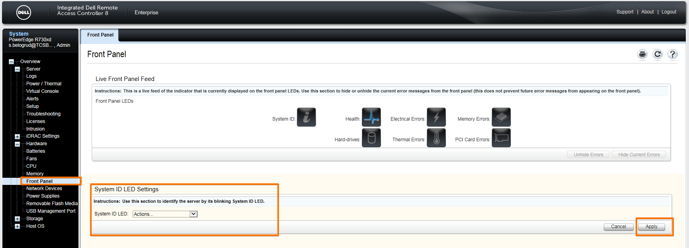

20151126

[root@ds-gp-prd-sdw6 ~]# yum install srvadmin-omacore

[root@ds-gp-prd-sdw6 ~]# omreport -?

omreport Reports component properties.

The available command(s) are:

Command Description
about Product and version properties.
licenses Displays the digital licenses of the installed hardware devices.
preferences Report system preferences.
system System component properties.
chassis Chassis component properties.
storage Display storage component properties.

Usage: omreport <command...> [name=value...] ... [option...]

Valid command line options are:
-? Print available command(s) or command help.
-fmt <lst|tbl|ssv|cdv|xml> Format for output results, default is lst.
Where: lst List format.
tbl Table format.
ssv Semicolon separated format.
cdv Custom delimiter separated format.
xml Raw XML format.
-outc <file> Redirect output to file, delete old if exists.
OR
-outa <file> Redirect output to file, append to old if exists.
OR
Output may also be redirected using Operating System facilities (e.g. |more).

[root@ds-gp-prd-sdw6 ~]#

# Here is how to get idrac ip-address info from local server.
[root@ds-gp-prd-sdw6 ~]# omreport chassis remoteaccess
Remote Access Information

Remote Access Device
Device Type : iDRAC8 Enterprise
iDRAC Ports : Present
IPMI Version : 2.0
System GUID : 3236374f-c0b3-5680-4310-004b4c4c4544
Number of Possible Active Sessions : 5
Number of Current Active Sessions : 0
Enable IPMI Over LAN : No
SOL Enabled : Yes
MAC Address : 18-FB-7B-9D-AD-FB

IPv4 Address
IP Address Source : Static
IP Address : 10.219.11.79
IP Subnet : 255.255.255.0
IP Gateway : 10.219.11.254

[root@ds-gp-prd-sdw6 ~]#

[root@ds-gp-prd-sdw6 ~]# omreport chassis info
Chassis Information

Index : 0
Chassis Name : Main System Chassis
Host Name : ds-gp-prd-sdw6
iDRAC8 Version : 2.15.10.10 (Build 8)
Lifecycle Controller Version : 2.15.10.10
Chassis Model : PowerEdge R730xd
Chassis Lock : Present
Chassis Service Tag : 3KCV762
Express Service Code : 7761281546
Chassis Asset Tag : Unknown
Flash chassis identify LED state : Off
Flash chassis identify LED timeout value : 300

[root@ds-gp-prd-sdw6 ~]#

[root@ds-gp-prd-sdw6 ~]# omreport chassis
Health

Main System Chassis

SEVERITY : COMPONENT
Ok : Fans
Ok : Intrusion
Ok : Memory
Ok : Power Supplies
Ok : Power Management
Ok : Processors
Ok : Temperatures
Ok : Voltages
Ok : Hardware Log
Ok : Batteries

For further help, type the command followed by -?

[root@ds-gp-prd-sdw6 ~]#

[root@ds-gp-prd-sdw6 ~]# omreport chassis firmware
Firmware Information

Version Information
iDRAC8 : 2.15.10.10 (Build 8)
Lifecycle Controller : 2.15.10.10

[root@ds-gp-prd-sdw6 ~]#

[root@ds-gp-prd-sdw6 ~]# omreport chassis bios
BIOS Information

Manufacturer : Dell Inc.
Version : 1.3.6
Release Date : 06/03/2015

[root@ds-gp-prd-sdw6 ~]#

[root@ds-gp-prd-sdw6 ~]# omreport system summary
System Summary

------------------
Software Profile
------------------
Systems Management
Name : Dell OpenManage Server Administrator
Version : 8.1.0
Description : Systems Management Software
Contains : A library for parsing GNU style command line arguments 8.1.0
: Data Engine 8.1.0
: Data Engine SNMP 8.1.0
: Disney SNMP 8.1.0
: Hardware Abstraction Programming Interface 8.1.0
: Instrumentation Services 8.1.0
: Meta package for installing the Server Administrator snmp component 8.1.0
: Meta package for installing the Server Administrator storage snmp component 8.1.0
: Meta package for installing the Server Agent 8.1.0
: NVMe Library 8.1.0
: OpenManage Inventory Collector 8.1.0
: RealSSD package for storage management 8.1.0
: Remote Access Card Data Populator 8.1.0
: Server Administrator CLI 8.1.0
: Server Administrator Common Framework 8.1.0
: Server Administrator Common Services 8.1.0
: Server Administrator Core 8.1.0
: Server Administrator XML Support SDK 8.1.0
: Storage Management SNMP component 5.0.1
: Storage Management System Utilities Package / Libsysfs 1.3.0
: Storage Management accessors package 5.0.1
: Storage Management common files for GUI and CLI 5.0.1
: StoreLib package for storage management 8.1.0
: System Utilities Package/Libsysfs for LSI storage libraries 2.1.0
: iDRAC SNMP components 8.1.0
: iDRAC6 Command Interface 8.1.0
: iDRAC7 Command Interface 8.1.0

Operating System
Name : Red Hat Enterprise Linux Server
Version : release 6.6 (Santiago) Kernel 2.6.32-504.el6.x86_64 (x86_64)
System Time : Thu Nov 26 12:15:00 2015
System Bootup Time : Wed Nov 25 18:03:25 2015

--------
System
--------
System
Host Name : ds-gp-prd-sdw6
System Location : Please set the value
Lifecycle Controller : Enabled

---------------------
Main System Chassis
---------------------
Chassis Information
Chassis Model : PowerEdge R730xd
Chassis Service Tag : 3KCV762
Express Service Code : 7761281546
Chassis Lock : Present
Chassis Asset Tag : Unknown
Node Id : 3KCV762

Remote Access Information
Remote Access Device : iDRAC8 Enterprise
vFlash Media : Absent

Processor 1
Processor Brand : Intel(R) Xeon(R) CPU E5-2650 v3 @ 2.30GHz
Processor Version : Model 63 Stepping 2
Voltage : 1300 mV

Processor 2
Processor Brand : Intel(R) Xeon(R) CPU E5-2650 v3 @ 2.30GHz
Processor Version : Model 63 Stepping 2
Voltage : 1300 mV

Memory
Total Installed Capacity : 196608 MB
Memory Available to the OS : 193587 MB
Total Maximum Capacity : 1572864 MB
Memory Array Count : 1

Memory Array 1
Location : System Board or Motherboard
Use : System Memory
Installed Capacity : 196608 MB
Maximum Capacity : 1572864 MB
Slots Available : 24
Slots Used : 12
ECC Type : Multibit ECC

Slot PCIe Slot 1
Adapter : [Not Occupied]
Type : PCI E Gen 3 X16
Data Bus Width : 8x or x8
Speed : [Not Obtained, see card documentation]
Slot Length : Long
Voltage Supply : 3.3 Volts

Slot PCIe Slot 2
Adapter : [Not Occupied]
Type : PCI E Gen 3 X16
Data Bus Width : 8x or x8
Speed : [Not Obtained, see card documentation]
Slot Length : Long
Voltage Supply : 3.3 Volts

Slot PCIe Slot 3
Adapter : PERC H730P Adapter
Type : PCI E Gen 3 X16
Data Bus Width : 8x or x8
Speed : [Not Obtained, see card documentation]
Slot Length : Long
Voltage Supply : 3.3 Volts

Slot PCIe Slot 4
Adapter : [Not Occupied]
Type : PCI E Gen 3
Data Bus Width : 16x or x16
Speed : [Not Obtained, see card documentation]
Slot Length : Long
Voltage Supply : 3.3 Volts

Slot PCIe Slot 5
Adapter : [Not Occupied]
Type : PCI E Gen 3 X16
Data Bus Width : 8x or x8
Speed : [Not Obtained, see card documentation]
Slot Length : Long
Voltage Supply : 3.3 Volts

Slot PCIe Slot 6
Adapter : [Not Occupied]
Type : PCI E Gen 3
Data Bus Width : 16x or x16
Speed : [Not Obtained, see card documentation]
Slot Length : Long
Voltage Supply : 3.3 Volts

BIOS Information
Manufacturer : Dell Inc.
Version : 1.3.6
Release Date : 06/03/2015

Firmware Information
Name : iDRAC8
Version : 2.15.10.10 (Build 8)

Firmware Information
Name : Lifecycle Controller
Version : 2.15.10.10

--------------------------
Remote Access Controller
--------------------------
Remote Access Controller Information
Product : iDRAC8 Enterprise
IP Address : 10.219.11.79
IP Subnet : 255.255.255.0
IP Gateway : 10.219.11.254
IPv6 Address 1 : ::
IPv6 Address 2 : ::
IPv6 Gateway : ::

--------------
Network Data
--------------
Network Interface 0
IP Address : 10.216.2.206
Subnet Mask : 255.255.255.0
Default Gateway : 10.216.2.254
MAC Address : 44:A8:42:32:06:3E

Network Interface 1
IP Address : 10.216.3.206
Subnet Mask : 255.255.255.0
Default Gateway : 10.216.3.254
MAC Address : 44:A8:42:32:06:40

Network Interface 2
IP Address : [No Value]
MAC Address : 44:A8:42:32:06:42

Network Interface 3
IP Address : [No Value]
MAC Address : 44:A8:42:32:06:44

[root@ds-gp-prd-sdw6 ~]#

[root@ds-gp-prd-sdw6 ~]# omreport chassis biossetup

Operation is under progress, it may take few seconds to complete...

Note: use display=shortnames optional parameter to see attribute names and setting values in short form.
BIOS Setup

System Information
------------------------------------------
System Model Name : PowerEdge R730xd
System BIOS Version : 1.3.6
System Management Engine Version : 3.0.7.164
System Service Tag : 3KCV762
System Manufacturer : Dell Inc.
System Manufacturer Contact Information : www.dell.com
System CPLD Version : 1.0.1
UEFI Compliance Version : 2.3.1

Memory Settings
------------------------------------------
System Memory Size : 192 GB
System Memory Type : ECC DDR4
System Memory Speed : 2133 Mhz
System Memory Voltage : 1.20 V
Video Memory : 16 MB
System Memory Testing : Disabled
Memory Operating Mode : Optimizer Mode
Node Interleaving : Disabled
Snoop Mode : Early Snoop
Correctable Memory ECC SMI : Enabled

Processor Settings
------------------------------------------
Logical Processor : Enabled
QPI Speed : Maximum data rate
Alternate RTID (Requestor Transaction ID) Setting : Disabled
Virtualization Technology : Enabled
Address Translation Services (ATS) : Enabled
Adjacent Cache Line Prefetch : Enabled
Hardware Prefetcher : Enabled
DCU Streamer Prefetcher : Enabled
DCU IP Prefetcher : Enabled
Logical Processor Idling : Disabled
Configurable TDP : Nominal
X2Apic Mode : Disabled
Dell Controlled Turbo : Disabled
Number of Cores per Processor : All
Processor 64-bit Support : Yes
Processor Core Speed : 2.30 GHz
Processor Bus Speed : 9.60 GT/s
Family-Model-Stepping : 6-3F-2
Brand : Intel(R) Xeon(R) CPU E5-2650 v3 @ 2.30GHz
Level 2 Cache : 10x256 KB
Level 3 Cache : 25 MB
Number of Cores : 10
Family-Model-Stepping : 6-3F-2
Brand : Intel(R) Xeon(R) CPU E5-2650 v3 @ 2.30GHz
Level 2 Cache : 10x256 KB
Level 3 Cache : 25 MB
Number of Cores : 10

SATA Settings
------------------------------------------
Embedded SATA : AHCI Mode
Security Freeze Lock : Enabled
Write Cache : Disabled
Port A : Auto
Model : Not Enumerated
Drive Type : Not Enumerated
Capacity : N/A
Port B : Auto
Model : Not Enumerated
Drive Type : Not Enumerated
Capacity : N/A

Boot Settings
------------------------------------------
Boot Mode : BIOS
Boot Sequence Retry : Enabled
Hard-Disk Failover : Disabled

BIOS Boot Settings
------------------------------------------

Boot Sequence
: 0. Enabled: Integrated NIC 1 Port 1 Partition 1: QLogic MBA Slot 0100 v7.12.6
: 1. Enabled: Hard drive C:

Hard-Disk Drive Sequence
: 0. Integrated RAID Controller 1: PERC H730P Mini(bus 02 dev 00)
: 1. RAID Controller in Slot 3: PERC H730P Adapter(bus 83 dev 00)

One-Time Boot
------------------------------------------
One-Time Boot Device List : Disabled
BIOS Boot Sequence Device : Integrated NIC 1 Port 1 Partition 1: QLogic MBA Slot 0100 v7.12.6
BIOS Hard-Disk Drive Sequence Device : Integrated RAID Controller 1: PERC H730P Mini(bus 02 dev 00)

Integrated Devices
------------------------------------------
USB 3.0 Setting : Disabled
User Accessible USB Ports : All Ports On
Internal USB Port : On
Integrated RAID Controller : Enabled
Integrated Network Card 1 : Enabled
Integrated Network Card 1 Port 1 Boot Protocol : PXE
Integrated Network Card 1 Port 2 Boot Protocol : None
Integrated Network Card 1 Port 3 Boot Protocol : None
Integrated Network Card 1 Port 4 Boot Protocol : None
I/OAT DMA Engine : Disabled
Embedded Video Controller : Enabled
Current State of Embedded Video Controller : Enabled
SR-IOV Global Enable : Disabled
OS Watchdog Timer : Disabled
Memory Mapped I/O above 4GB : Enabled

Slot Disablement
------------------------------------------
Slot 1 : Enabled
Slot 2 : Enabled
Slot 3 : Enabled
Slot 4 : Enabled
Slot 5 : Enabled
Slot 6 : Enabled

Serial Communication
------------------------------------------
Serial Communication : Auto
Serial Port Address : Serial Device1=COM2,Serial Device2=COM1
External Serial Connector : Serial Device 1
Failsafe Baud Rate : 115200
Remote Terminal Type : VT100/VT220
Redirection After Boot : Enabled

System Profile Settings
------------------------------------------
System Profile : Performance
CPU Power Management : Maximum Performance
Memory Frequency : Maximum Performance
Turbo Boost : Enabled
Energy Efficient Turbo : Disabled
C1E : Disabled
C States : Disabled
Collaborative CPU Performance Control : Disabled
Memory Patrol Scrub : Standard
Memory Refresh Rate : 1x
Uncore Frequency : Maximum
Energy Efficient Policy : Performance
Number of Turbo Boost Enabled Cores for Processor 1 : All
Number of Turbo Boost Enabled Cores for Processor 2 : All
Monitor/Mwait : Enabled
Workload Profile : Not Available
Power Saver : Disabled

System Security
------------------------------------------
Intel(R) AES-NI : Enabled
System Password :
Setup Password :
Password Status : Unlocked
TPM Security : Off
TPM Information : No TPM present
TPM Status : Unknown
TPM Command : None
Intel(R) TXT : Off
AC Power Recovery : Last
AC Power Recovery Delay : Immediate
User Defined Delay (60s to 240s) : 0
UEFI Variable Access : Standard
Secure Boot : Disabled
Secure Boot Policy : Standard

Miscellaneous Settings
------------------------------------------
Asset Tag :
Keyboard NumLock : On
F1/F2 Prompt on Error : Enabled
Load Legacy Video Option ROM : Disabled
In-System Characterization : Enabled - No Reboot

[root@ds-gp-prd-sdw6 ~]#

[root@ds-gp-prd-sdw6 ~]# omreport chassis fru
System Components (FRU) Information

Device : System Planar (iDRAC8)
Serial No. : CN7016354M00AB
Part No. : 0H21J3
Revision : A07
Manufacturer : DELL
Manufacture Date : Thu Apr 23 12:15:00 2015

Device : Power Supply 1 (PS1)
Serial No. : PH1629856A007V
Part No. : 0TPJ2X
Revision : A02
Manufacturer : DELL
Manufacture Date : Wed Jun 10 12:26:00 2015

Device : Power Supply 2 (PS2)
Serial No. : PH1629856A007W
Part No. : 0TPJ2X
Revision : A02
Manufacturer : DELL
Manufacture Date : Wed Jun 10 12:27:00 2015

Device : Disk Drive Bay (BP1)
Serial No. : CN779214CM00I3
Part No. : 0DTCVP
Revision : A00
Manufacturer : DELL
Manufacture Date : Fri Jan 09 23:06:00 2015

Device : Add-in Card (NDC)
Serial No. : CN7792155P018E
Part No. : 0165T0
Revision : A00
Manufacturer : DELL
Manufacture Date : Wed May 25 02:00:00 2005

Device : Add-in Card (PERC1)
Serial No. : CN7792155L01BE
Part No. : 07H4CN
Revision : A01
Manufacturer : DELL
Manufacture Date : Thu May 28 00:33:00 2015

Device : A1
Serial No. : 40177310
Part No. : M393A2G40DB0-CPB
Revision : N/A
Manufacturer : Samsung (00CE00B300CE)
Manufacture Date : Mon Feb 23 15:00:00 2015

Device : A2
Serial No. : 401772FD
Part No. : M393A2G40DB0-CPB
Revision : N/A
Manufacturer : Samsung (00CE00B300CE)
Manufacture Date : Mon Feb 23 15:00:00 2015

Device : A3
Serial No. : 40177301
Part No. : M393A2G40DB0-CPB
Revision : N/A
Manufacturer : Samsung (00CE00B300CE)
Manufacture Date : Mon Feb 23 15:00:00 2015

Device : A4
Serial No. : 40177339
Part No. : M393A2G40DB0-CPB
Revision : N/A
Manufacturer : Samsung (00CE00B300CE)
Manufacture Date : Mon Feb 23 15:00:00 2015

Device : A5
Serial No. : 40177164
Part No. : M393A2G40DB0-CPB
Revision : N/A
Manufacturer : Samsung (00CE00B300CE)
Manufacture Date : Mon Feb 23 15:00:00 2015

Device : A6
Serial No. : 40177163
Part No. : M393A2G40DB0-CPB
Revision : N/A
Manufacturer : Samsung (00CE00B300CE)
Manufacture Date : Mon Feb 23 15:00:00 2015

Device : B1
Serial No. : 40177118
Part No. : M393A2G40DB0-CPB
Revision : N/A
Manufacturer : Samsung (00CE00B300CE)
Manufacture Date : Mon Feb 23 15:00:00 2015

Device : B2
Serial No. : 4017729A
Part No. : M393A2G40DB0-CPB
Revision : N/A
Manufacturer : Samsung (00CE00B300CE)
Manufacture Date : Mon Feb 23 15:00:00 2015

Device : B3
Serial No. : 40177321
Part No. : M393A2G40DB0-CPB
Revision : N/A
Manufacturer : Samsung (00CE00B300CE)
Manufacture Date : Mon Feb 23 15:00:00 2015

Device : B4
Serial No. : 401772FB
Part No. : M393A2G40DB0-CPB
Revision : N/A
Manufacturer : Samsung (00CE00B300CE)
Manufacture Date : Mon Feb 23 15:00:00 2015

Device : B5
Serial No. : 40177329
Part No. : M393A2G40DB0-CPB
Revision : N/A
Manufacturer : Samsung (00CE00B300CE)
Manufacture Date : Mon Feb 23 15:00:00 2015

Device : B6
Serial No. : 411DF5F4
Part No. : M393A2G40DB0-CPB
Revision : N/A
Manufacturer : Samsung (00CE00B300CE)
Manufacture Date : Mon Aug 24 15:00:00 2015

[root@ds-gp-prd-sdw6 ~]#

# Get detail about memory modules.
[root@ds-gp-prd-sdw7 ~]# omreport chassis memory

Memory Information

Health : Critical

Attributes of Memory Array(s)

Attributes of Memory Array(s)
Location : System Board or Motherboard
Use : System Memory
Installed Capacity : 196608 MB
Maximum Capacity : 1572864 MB
Slots Available : 24
Slots Used : 12
Error Correction : Multibit ECC

Total of Memory Array(s)
Total Installed Capacity : 196608 MB
Total Installed Capacity Available to the OS : 193587 MB
Total Maximum Capacity : 1572864 MB

Details of Memory Array 1
Index : 0
Status : Ok
Connector Name : A1
Type : DDR4 - Synchronous Registered (Buffered)
Size : 16384 MB

Index : 1
Status : Ok
Connector Name : A2
Type : DDR4 - Synchronous Registered (Buffered)
Size : 16384 MB

Index : 2
Status : Ok
Connector Name : A3
Type : DDR4 - Synchronous Registered (Buffered)
Size : 16384 MB

Index : 3
Status : Ok
Connector Name : A4
Type : DDR4 - Synchronous Registered (Buffered)
Size : 16384 MB

Index : 4
Status : Ok
Connector Name : A5
Type : DDR4 - Synchronous Registered (Buffered)
Size : 16384 MB

Index : 5
Status : Ok
Connector Name : A6
Type : DDR4 - Synchronous Registered (Buffered)
Size : 16384 MB

Index :
Status : Unknown
Connector Name : A7
Type : [Not Occupied]
Size :

Index :
Status : Unknown
Connector Name : A8
Type : [Not Occupied]
Size :

Index :
Status : Unknown
Connector Name : A9
Type : [Not Occupied]
Size :

Index :
Status : Unknown
Connector Name : A10
Type : [Not Occupied]
Size :

Index :
Status : Unknown
Connector Name : A11
Type : [Not Occupied]
Size :

Index :
Status : Unknown
Connector Name : A12
Type : [Not Occupied]
Size :

Index : 6
Status : Ok
Connector Name : B1
Type : DDR4 - Synchronous Registered (Buffered)
Size : 16384 MB

Index : 7
Status : Critical
Connector Name : B2
Type : DDR4 - Synchronous Registered (Buffered)
Size : 16384 MB

Index : 8
Status : Ok
Connector Name : B3
Type : DDR4 - Synchronous Registered (Buffered)
Size : 16384 MB

Index : 9
Status : Ok
Connector Name : B4
Type : DDR4 - Synchronous Registered (Buffered)
Size : 16384 MB

Index : 10
Status : Ok
Connector Name : B5
Type : DDR4 - Synchronous Registered (Buffered)
Size : 16384 MB

Index : 11
Status : Ok
Connector Name : B6
Type : DDR4 - Synchronous Registered (Buffered)
Size : 16384 MB

Index :
Status : Unknown
Connector Name : B7
Type : [Not Occupied]
Size :

Index :
Status : Unknown
Connector Name : B8
Type : [Not Occupied]
Size :

Index :
Status : Unknown
Connector Name : B9
Type : [Not Occupied]
Size :

Index :
Status : Unknown
Connector Name : B10
Type : [Not Occupied]
Size :

Index :
Status : Unknown
Connector Name : B11
Type : [Not Occupied]
Size :

Index :
Status : Unknown
Connector Name : B12
Type : [Not Occupied]
Size :

[root@ds-gp-prd-sdw7 ~]#

[root@ds-gp-prd-sdw7 ~]# omreport chassis memory index=7
Memory Device Information

Health : Critical

Status : Critical
Device Name : B2
Size : 16384 MB
Type : DDR4 Synchronous Registered (Buffered)
Speed : 0.47 ns
Rank : Dual
Failures : Single-bit warning error rate exceeded.Single-bit failure error rate exceeded.

[root@ds-gp-prd-sdw7 ~]#

[root@ds-gp-prd-sdw7 ~]# omreport chassis fru | grep -A 6 B2
Device : B2
Serial No. : 40179555
Part No. : M393A2G40DB0-CPB
Revision : N/A
Manufacturer : Samsung (00CE00B300CE)
Manufacture Date : Mon Feb 23 15:00:00 2015

[root@ds-gp-prd-sdw7 ~]#

# Other way to use grep. This way is more prefferable.
[root@m1-2-gp-prd-sdw36 ~]# omreport chassis fru | grep -A 6 -e "Device *: *A3"
Device : A3
Serial No. : 1626BB21
Part No. : 18ASF2G72PDZ-2G3B1
Revision : N/A
Manufacturer : Micron Technology (002C00B3002C)
Manufacture Date : Mon Mar 06 15:00:00 2017

[root@m1-2-gp-prd-sdw36 ~]#

20151203
# After memory module have replaced we can see, that module still in Critical state.
# But after cleaning procedure - everything become Ok.

[root@ds-gp-prd-sdw7 ~]# omreport chassis memory index=7
Memory Device Information

Health : Critical

Status : Critical
Device Name : B2
Size : 16384 MB
Type : DDR4 Synchronous Registered (Buffered)
Speed : 0.47 ns
Rank : Dual
Failures : Single-bit failure error rate exceeded.

[root@ds-gp-prd-sdw7 ~]# dcicfg command=clearmemfailures failures=all
Clearing failures using mask: 31
A1: ok
A2: ok
A3: ok
A4: ok
A5: ok
A6: ok
B1: ok
B2: ok
B3: ok
B4: ok
B5: ok
B6: ok
[root@ds-gp-prd-sdw7 ~]# omreport chassis memory index=7
Memory Device Information

Health : Ok

Status : Ok
Device Name : B2
Size : 16384 MB
Type : DDR4 Synchronous Registered (Buffered)
Speed : 0.47 ns
Rank : Dual
Failures : None

[root@ds-gp-prd-sdw7 ~]#

https://www.dell.com/support/article/ru/ru/rubsdc/sln131078/%D0%BA%D0%B0%D0%BA-%D0%BE%D1%87%D0%B8%D1%81%D1%82%D0%B8%D1%82%D1%8C-%D0%B6%D1%83%D1%80%D0%BD%D0%B0%D0%BB-sbe-%D0%B4%D0%BB%D1%8F-%D0%BC%D0%BE%D0%B4%D1%83%D0%BB%D1%8F-%D0%BF%D0%B0%D0%BC%D1%8F%D1%82%D0%B8-dimm-%D0%BD%D0%B0-%D1%81%D0%B5%D1%80%D0%B2%D0%B5%D1%80%D0%B5-dell-poweredge?lang=ru

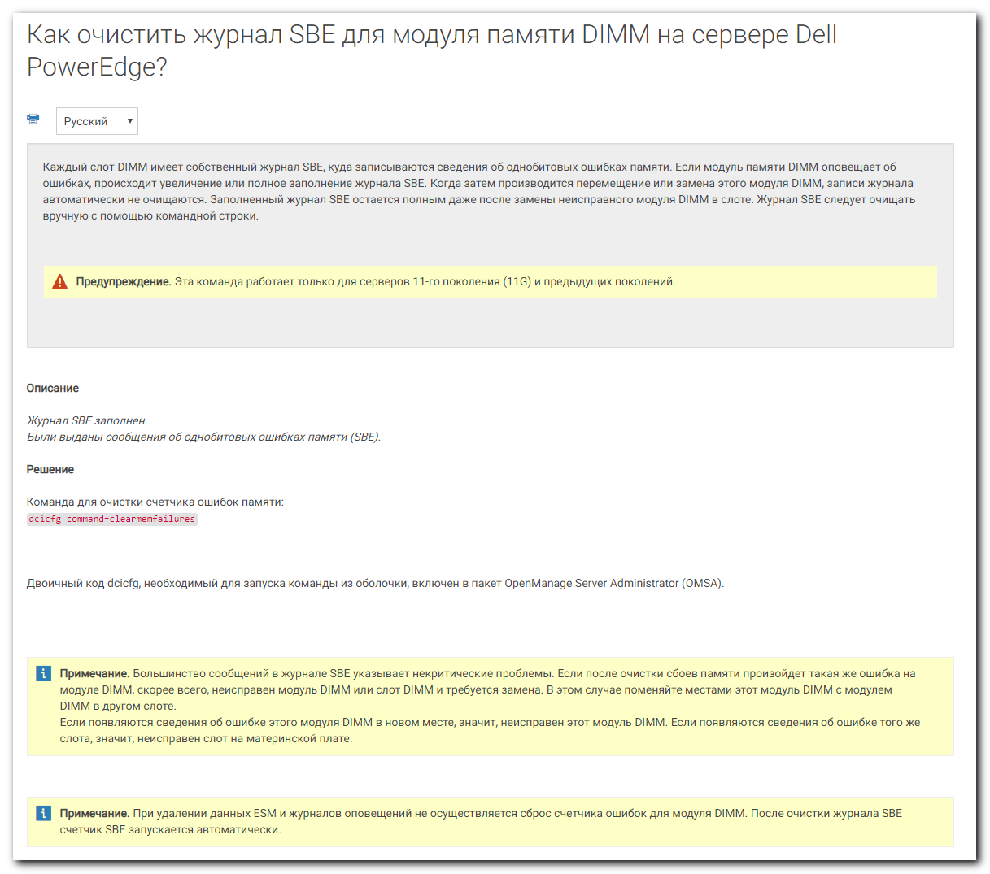
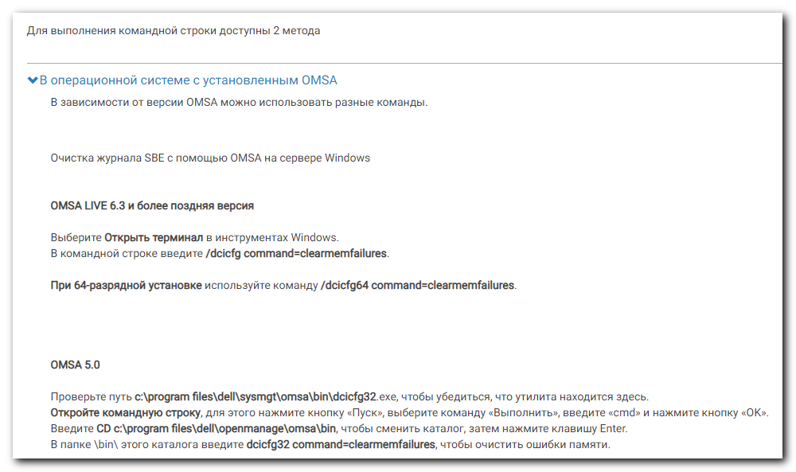
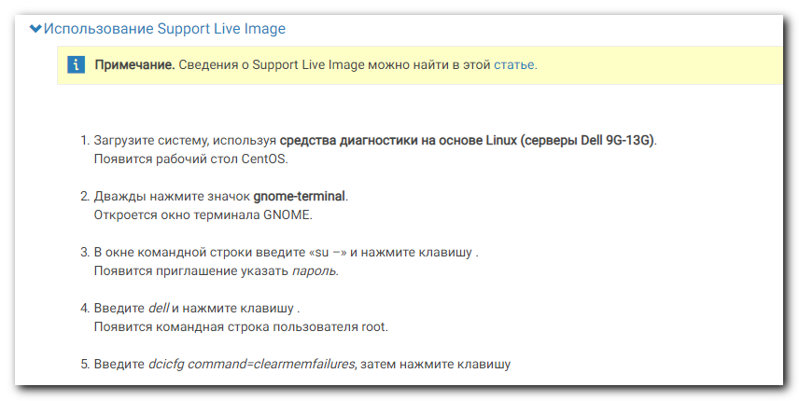

20151125
# Turn on LED indication on server.

[root@ds-gp-prd-sdw6 ~]#

[root@ds-gp-prd-sdw6 ~]# racadm setled -l 1
RAC0907 : System ID LED blink on.

[root@ds-gp-prd-sdw6 ~]#

[root@ds-gp-prd-sdw6 ~]# racadm getled
LED State : Blinking

[root@ds-gp-prd-sdw6 ~]#

[root@ds-gp-prd-sdw6 ~]# racadm help setled
setled -- Set the state of the LED on a module.

Usage:

racadm setled [-l <ledState>]

Options:

-l <ledState> 0 = No blinking, 1 = Blinking

Examples:

From the iDRAC make the LED blink
$ racadm setled -l 1
LED state was set successfully

From the iDRAC stop the LED from blinking
$ racadm setled -l 0
LED state was cleared successfully

For help on viewing the properties of a group, run the command - racadm help get
For help on configuring the properties of a group, run the command - racadm help set

-----------------------------------------------------------------------

[root@ds-gp-prd-sdw6 ~]#

http://www.dell.com/support/manuals/us/en/19/integrated-dell-remote-access-cntrllr-8-with-lifecycle-controller-v2.00.00.00/racadm_idrac_pub-v1/storage?guid=GUID-9E3676CB-B71D-420B-8C48-C80ADD258E03&lang=en-us
20160725
# Turn on LED on hard drive.
[root@ds-gp-prd-sdw24 20160722-1746]# racadm storage blink:Disk.Bay.2:Enclosure.Internal.0-1:RAID.Integrated.1-1
STOR095 : Storage operation is successfully completed.

[root@ds-gp-prd-sdw24 20160722-1746]#

# Turn off LED indication on hard drive.
[root@ds-gp-prd-sdw24 20160722-1746]# racadm storage unblink:Disk.Bay.2:Enclosure.Internal.0-1:RAID.Integrated.1-1
STOR095 : Storage operation is successfully completed.

[root@ds-gp-prd-sdw24 20160722-1746]#

20151201
# Display only records started from defined number.
[root@ds-gp-prd-sdw7 ~]# racadm getsel -s 5
Record: 5
Date/Time: 10/08/2015 19:23:00
Source: system
Severity: Ok
Description: Drive 13 is installed in disk drive bay 1.
-------------------------------------------------------------------------------
Record: 6
Date/Time: 12/01/2015 11:48:01
Source: system
Severity: Non-Critical
Description: Correctable memory error rate exceeded for DIMM_B2.
-------------------------------------------------------------------------------
Record: 7
Date/Time: 12/01/2015 11:48:09
Source: system
Severity: Critical
Description: Correctable memory error rate exceeded for DIMM_B2.
-------------------------------------------------------------------------------

[root@ds-gp-prd-sdw7 ~]#

# Same as above, but with other utility.
[root@ds-gp-prd-sdw7 ~]# omreport system alertlog | head -n 11
Alert Log

Alert Log contains...

Severity : Critical
ID : 1404
Date and Time : Tue Dec 1 11:48:16 2015
Category : Instrumentation Service
Description : Memory device status is critical
Memory device location: B2
Possible memory module event cause:Single bit warning error rate exceeded,Single bit failure error rate exceeded
omreportUnsuccessful command execution!
[root@ds-gp-prd-sdw7 ~]#

20151124
# Get messages from log about some out of order details.
[root@ds-gp-prd-sdw6 ~]# racadm getsel
Record: 1
Date/Time: 08/20/2015 15:42:26
Source: system
Severity: Ok
Description: Log cleared.
-------------------------------------------------------------------------------
Record: 2
Date/Time: 11/24/2015 10:13:38
Source: system
Severity: Non-Critical
Description: Correctable memory error rate exceeded for DIMM_B6.
-------------------------------------------------------------------------------

[root@ds-gp-prd-sdw6 ~]#

# Here is detail about hardware state.
[root@ds-gp-prd-sdw6 ~]# racadm getsensorinfo
…
Sensor Type : MEMORY
<Sensor Name> <Status> <State> <lc> <uc>
DIMM A1 Ok Presence Detected NA NA
DIMM A2 Ok Presence Detected NA NA
DIMM A3 Ok Presence Detected NA NA
DIMM A4 Ok Presence Detected NA NA
DIMM A5 Ok Presence Detected NA NA
DIMM A6 Ok Presence Detected NA NA
DIMM A7 N/A Absent NA NA
DIMM A8 N/A Absent NA NA
DIMM A9 N/A Absent NA NA
DIMM A10 N/A Absent NA NA
DIMM A11 N/A Absent NA NA
DIMM A12 N/A Absent NA NA
DIMM B1 Ok Presence Detected NA NA
DIMM B2 Ok Presence Detected NA NA
DIMM B3 Ok Presence Detected NA NA
DIMM B4 Ok Presence Detected NA NA
DIMM B5 Ok Presence Detected NA NA
DIMM B6 Warning Presence Detected NA NA
DIMM B7 N/A Absent NA NA
DIMM B8 N/A Absent NA NA
DIMM B9 N/A Absent NA NA
DIMM B10 N/A Absent NA NA
DIMM B11 N/A Absent NA NA
DIMM B12 N/A Absent NA NA
…

# Get idrac ip-address and other usefull info (Service Tag, Model and so on).
[root@ds-gp-prd-sdw6 ~]# racadm getsysinfo
…
IPv4 settings:
Enabled = 1
Current IP Address = 10.219.11.79
Current IP Gateway = 10.219.11.254
Current IP Netmask = 255.255.255.0
DHCP Enabled = 0
Current DNS Server 1 = 0.0.0.0
Current DNS Server 2 = 0.0.0.0
DNS Servers from DHCP = Disabled
...
System Information:
System Model = PowerEdge R730xd
System Revision = I
System BIOS Version = 1.3.6
Service Tag = 3KCV762
Express Svc Code = 7761281546
Host Name = sdw6
OS Name = Red Hat Enterprise Linux Server
OS Version = release 6.6 (Santiago) Kernel 2.6.32-504.el6.x86_64 (x86_64)
Power Status = ON
Fresh Air Capable = Yes
…

# Here we can see LED status on this server.
[root@ds-gp-prd-sdw6 ~]# racadm getled
LED State : Not-Blinking

[root@ds-gp-prd-sdw6 ~]#

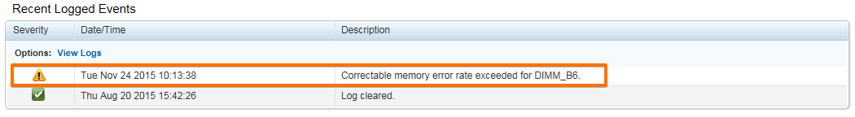

Normal,"Thu Aug 20 2015 15:42:26","Log cleared."
Warning,"Tue Nov 24 2015 10:13:38","Correctable memory error rate exceeded for DIMM_B6."

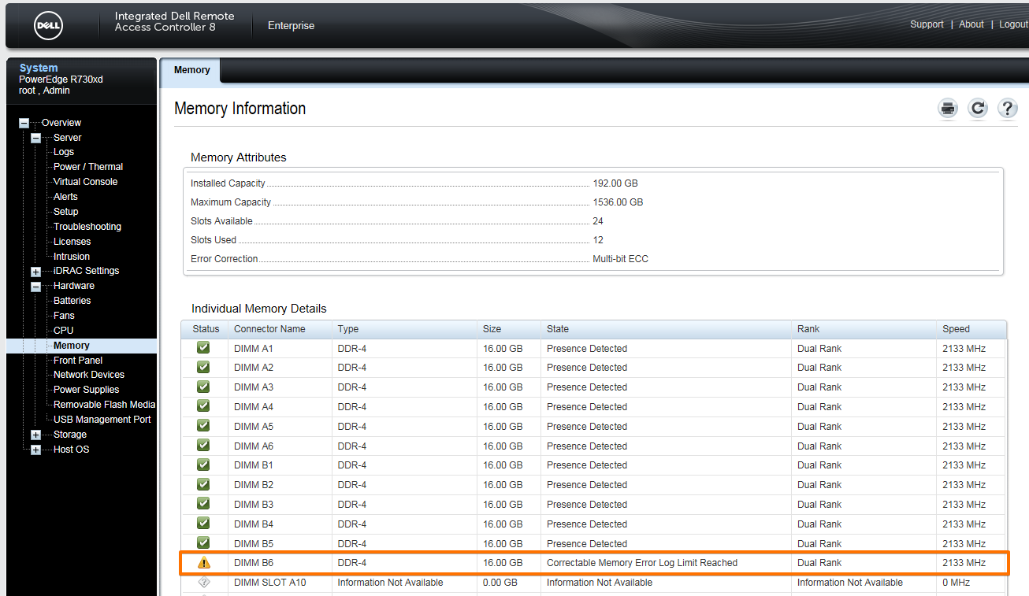

# Get last ten logged messages of idrac.
[root@ds-gp-prd-sdw6 ~]# racadm getraclog -c 10
SeqNumber = 162
Message ID = ISM0004
Category = Audit
AgentID = Unknown
Severity = Information
Timestamp = 2015-08-25 10:12:09
Message = The iDRAC Service Module has successfully started communication with iDRAC.
--------------------------------------------------------------------------------
...

20151008
# Operating with Dell hard drives.

[root@ds-gp-prd-sdw7 ~]# racadm storage get vdisks -o -p layout,status
Disk.Virtual.0:RAID.Integrated.1-1
Layout = Raid-1
Status = Ok
Disk.Virtual.0:RAID.Slot.3-1
Layout = Raid-10
Status = Warning
Disk.Virtual.1:RAID.Integrated.1-1
Layout = Raid-10
Status = Ok

[root@ds-gp-prd-sdw7 ~]#

[root@ds-gp-prd-sdw7 ~]# racadm storage get pdisks -o -p status
Disk.Bay.0:Enclosure.Internal.0-1:RAID.Integrated.1-1
Status = Ok
Disk.Bay.1:Enclosure.Internal.0-1:RAID.Integrated.1-1
Status = Ok
Disk.Bay.2:Enclosure.Internal.0-1:RAID.Integrated.1-1
Status = Ok
Disk.Bay.3:Enclosure.Internal.0-1:RAID.Integrated.1-1
Status = Ok
Disk.Bay.4:Enclosure.Internal.0-1:RAID.Integrated.1-1
Status = Ok
Disk.Bay.5:Enclosure.Internal.0-1:RAID.Integrated.1-1
Status = Ok
Disk.Bay.6:Enclosure.Internal.0-1:RAID.Integrated.1-1
Status = Ok
Disk.Bay.7:Enclosure.Internal.0-1:RAID.Integrated.1-1
Status = Ok
Disk.Bay.8:Enclosure.Internal.0-1:RAID.Integrated.1-1
Status = Ok
Disk.Bay.12:Enclosure.Internal.0-1:RAID.Slot.3-1
Status = Ok
Disk.Bay.13:Enclosure.Internal.0-1:RAID.Slot.3-1
Status = Failed
Disk.Bay.14:Enclosure.Internal.0-1:RAID.Slot.3-1
Status = Ok
Disk.Bay.15:Enclosure.Internal.0-1:RAID.Slot.3-1
Status = Ok
Disk.Bay.16:Enclosure.Internal.0-1:RAID.Slot.3-1
Status = Ok
Disk.Bay.17:Enclosure.Internal.0-1:RAID.Slot.3-1
Status = Ok
Disk.Bay.18:Enclosure.Internal.0-1:RAID.Slot.3-1
Status = Ok
Disk.Bay.19:Enclosure.Internal.0-1:RAID.Slot.3-1
Status = Ok
Disk.Bay.9:Enclosure.Internal.0-1:RAID.Integrated.1-1
Status = Ok

[root@ds-gp-prd-sdw7 ~]#

[root@ds-gp-prd-sdw7 ~]# racadm storage get pdisks:Disk.Bay.13:Enclosure.Internal.0-1:RAID.Slot.3-1
Disk.Bay.13:Enclosure.Internal.0-1:RAID.Slot.3-1
Status = Failed
DeviceDescription = Disk 13 in Backplane 1 of RAID Controller in Slot 3
RollupStatus = Failed
Name = Physical Disk 0:1:13
State = Failed
OperationState = Not Applicable
PowerStatus = Spun-Up
Size = 558.38 GB
FailurePredicted = NO
RemainingRatedWriteEndurance = Not Applicable
SecurityStatus = Not Capable
BusProtocol = SAS
MediaType = HDD
UsedRaidDiskSpace = 558.38 GB
AvailableRaidDiskSpace = 558.38 GB
Hotspare = NO
Manufacturer = TOSHIBA
ProductId = AL13SEB600
Revision = DE11
SerialNumber = 6590A03LFRD3
PartNumber = PH05TFDD7557156CFKXJA06
NegotiatedSpeed = 6.0 Gb/s
ManufacturedDay = 6
ManufacturedWeek = 24
ManufacturedYear = 2015
SasAddress = 0x500003965808297E
FormFactor = 2.5 Inch
RaidNominalMediumRotationRate = 10000
T10PICapability = Not Capable
BlockSizeInBytes = 512
MaxCapableSpeed = 6 Gb/s

[root@ds-gp-prd-sdw7 ~]#

# When hard drive has been removed from server.
[root@ds-gp-prd-sdw7 ~]# racadm storage get pdisks:Disk.Bay.13:Enclosure.Internal.0-1:RAID.Slot.3-1
Disk.Bay.13:Enclosure.Internal.0-1:RAID.Slot.3-1
Status = Failed
DeviceDescription = Disk 13 in Backplane 1 of RAID Controller in Slot 3
RollupStatus = Failed
Name = Physical Disk 0:1:13
State = Removed
OperationState = Not Applicable
PowerStatus = Spun-Up
Size = 558.38 GB
FailurePredicted = NO
RemainingRatedWriteEndurance = Not Applicable
SecurityStatus = Not Capable
BusProtocol = SAS
MediaType = HDD
UsedRaidDiskSpace = 558.38 GB
AvailableRaidDiskSpace = 558.38 GB
Hotspare = NO
Manufacturer = TOSHIBA
ProductId = AL13SEB600
Revision = DE11
SerialNumber = 6590A03LFRD3
PartNumber = PH05TFDD7557156CFKXJA06
NegotiatedSpeed = 6.0 Gb/s
ManufacturedDay = 6
ManufacturedWeek = 24
ManufacturedYear = 2015
SasAddress = 0x500003965808297E
FormFactor = 2.5 Inch
RaidNominalMediumRotationRate = 10000
T10PICapability = Not Capable
BlockSizeInBytes = 512
MaxCapableSpeed = 6 Gb/s

[root@ds-gp-prd-sdw7 ~]#

# After 30 seconds when new hard drive have been inserted.
[root@ds-gp-prd-sdw7 ~]# racadm storage get pdisks:Disk.Bay.13:Enclosure.Internal.0-1:RAID.Slot.3-1
Disk.Bay.13:Enclosure.Internal.0-1:RAID.Slot.3-1
Status = Ok
DeviceDescription = Disk 13 in Backplane 1 of RAID Controller in Slot 3
RollupStatus = Ok
Name = Physical Disk 0:1:13
State = Online
OperationState = Rebuilding
Progress = 1 %
PowerStatus = Spun-Up
Size = 558.38 GB
FailurePredicted = NO
RemainingRatedWriteEndurance = Not Applicable
SecurityStatus = Not Capable
BusProtocol = SAS
MediaType = HDD
UsedRaidDiskSpace = 558.38 GB
AvailableRaidDiskSpace = 0.00 GB
Hotspare = NO
Manufacturer = SEAGATE
ProductId = ST600MM0006
Revision = LS0A
SerialNumber = S0M5SQW4
PartNumber = CN07YX587262256T00QHA02
NegotiatedSpeed = 6.0 Gb/s
ManufacturedDay = 4
ManufacturedWeek = 27
ManufacturedYear = 2015
SasAddress = 0x5000C50089D7B789
FormFactor = 2.5 Inch
RaidNominalMediumRotationRate = 10000
T10PICapability = Not Capable
BlockSizeInBytes = 512
MaxCapableSpeed = 6 Gb/s

[root@ds-gp-prd-sdw7 ~]#

[root@ds-gp-prd-sdw7 ~]# racadm storage get pdisks:Disk.Bay.13:Enclosure.Internal.0-1:RAID.Slot.3-1 -p Status,OperationState,Progress
Disk.Bay.13:Enclosure.Internal.0-1:RAID.Slot.3-1
Status = Ok
OperationState = Rebuilding
Progress = 5 %

[root@ds-gp-prd-sdw7 ~]#

[root@ds-gp-prd-sdw7 ~]# racadm storage get pdisks -o -p name,status
Disk.Bay.0:Enclosure.Internal.0-1:RAID.Integrated.1-1
Name = Physical Disk 0:1:0
Status = Ok
Disk.Bay.1:Enclosure.Internal.0-1:RAID.Integrated.1-1
Name = Physical Disk 0:1:1
Status = Ok
Disk.Bay.2:Enclosure.Internal.0-1:RAID.Integrated.1-1
Name = Physical Disk 0:1:2
Status = Ok
Disk.Bay.3:Enclosure.Internal.0-1:RAID.Integrated.1-1
Name = Physical Disk 0:1:3
Status = Ok
Disk.Bay.4:Enclosure.Internal.0-1:RAID.Integrated.1-1
Name = Physical Disk 0:1:4
Status = Ok
Disk.Bay.5:Enclosure.Internal.0-1:RAID.Integrated.1-1
Name = Physical Disk 0:1:5
Status = Ok
Disk.Bay.6:Enclosure.Internal.0-1:RAID.Integrated.1-1
Name = Physical Disk 0:1:6
Status = Ok
Disk.Bay.7:Enclosure.Internal.0-1:RAID.Integrated.1-1
Name = Physical Disk 0:1:7
Status = Ok
Disk.Bay.8:Enclosure.Internal.0-1:RAID.Integrated.1-1
Name = Physical Disk 0:1:8
Status = Ok
Disk.Bay.12:Enclosure.Internal.0-1:RAID.Slot.3-1
Name = Physical Disk 0:1:12
Status = Ok
Disk.Bay.13:Enclosure.Internal.0-1:RAID.Slot.3-1
Name = Physical Disk 0:1:13
Status = Failed
Disk.Bay.14:Enclosure.Internal.0-1:RAID.Slot.3-1
Name = Physical Disk 0:1:14
Status = Ok
Disk.Bay.15:Enclosure.Internal.0-1:RAID.Slot.3-1
Name = Physical Disk 0:1:15
Status = Ok
Disk.Bay.16:Enclosure.Internal.0-1:RAID.Slot.3-1
Name = Physical Disk 0:1:16
Status = Ok
Disk.Bay.17:Enclosure.Internal.0-1:RAID.Slot.3-1
Name = Physical Disk 0:1:17
Status = Ok
Disk.Bay.18:Enclosure.Internal.0-1:RAID.Slot.3-1
Name = Physical Disk 0:1:18
Status = Ok
Disk.Bay.19:Enclosure.Internal.0-1:RAID.Slot.3-1
Name = Physical Disk 0:1:19
Status = Ok
Disk.Bay.9:Enclosure.Internal.0-1:RAID.Integrated.1-1
Name = Physical Disk 0:1:9
Status = Ok

[root@ds-gp-prd-sdw7 ~]#

[root@ds-gp-prd-sdw7 ~]# racadm storage get controllers:RAID.Slot.3-1
RAID.Slot.3-1
Status = Ok
DeviceDescription = RAID Controller in Slot 3
RollupStatus = Warning
Name = PERC H730P Adapter (PCI Slot 3)
PciSlot = 3
FirmwareVersion = 25.3.0.0016
DriverVersion = --NA--
RebuildRate = 30
BgiRate = 30
CheckConsistencyRate = 30
ReconstructRate = 30
PatrolReadRate = 30
PatrolReadMode = Automatic
PatrolReadState = Stopped
CheckConsistencyMode = Normal
LoadBalanceSetting = Auto
CopybackMode = ON
PreservedCache = Not Present
CacheMemorySize = 2048 MB
PersistHotspare = Disabled
SpindownUnconfiguredDrives = Disabled
SpindownHotspare = Disabled
Timeintervalforspindown = 30 (Minutes)
SecurityStatus = Encryption Capable
EncryptionMode = None
SasAddress = 0x544A842031B66100
PciDeviceId = 0x5d
PciSubdeviceId = 0x1f42
PciVendorId = 0x1000
PciSubvendorId = 0x1028
PciBus = 0x83
PciDevice = 0x0
PciFunction = 0x0
BusWidth = 8x or x8
SlotLength = Long Length
SlotType = PCI Express Gen3 x16
MaxCapableSpeed = 12.0 Gb/s
LearnMode = Not supported
T10PICapability = Capable
SupportRAID10UnevenSpans = Supported
SupportEnhancedAutoForeignImport = Supported
EnhancedAutoImportForeignConfig = Disabled
SupportControllerBootMode = Supported
ControllerBootMode = Continue Boot On Error
RealtimeConfigurationCapability = Capable
CurrentControllerMode = RAID

[root@ds-gp-prd-sdw7 ~]#

[root@ds-gp-prd-sdw7 ~]# racadm storage get controllers -o -p name,status
RAID.Integrated.1-1
Name = PERC H730P Mini (Embedded)
Status = Ok
RAID.Slot.3-1
Name = PERC H730P Adapter (PCI Slot 3)
Status = Ok

[root@ds-gp-prd-sdw7 ~]#

[root@ds-gp-prd-sdw7 ~]# racadm help raid
Storage monitoring, inventory and configuration of hardware RAID connected to the server.

Usage :

racadm storage get status
racadm storage get <Object type I>
racadm storage get <Object type I> -o
racadm storage get <Object type I> -o -p <property names separated by comma>
racadm storage get <Object type I>:<FQDD's of Object type separated by comma>
-p <property names separated by comma>
racadm storage get <Object type I>:<FQDD's of Object type separated by comma>
racadm storage get <Object type II> --refkey <reference keys separated by comma>
racadm storage get <Object type II> --refkey <reference keys separated by comma> -o
racadm storage get <Object type II> --refkey <reference keys separated by comma> -o
-p <property names separated by comma>
racadm storage <Object type III>:<FQDD>
racadm storage hotspare:<Physical Disk FQDD> -assign yes -type dhs -vdkey:<FQDD of VD>
racadm storage init:<VD FQDD> -speed fast }
racadm storage createvd:<Controller FQDD> -rl {r0|r1|r5|r6|r10|r50|r60} [-wp {wt|wb}] [-rp {nra|ra|ara}]
[-ss {1k|2k|4k|8k|16k|32k|64k|128k|256k|512k|1M|2M|4M|8M|16M}] -pdkey:<comma separated PD FQDD>
[-dcp {enabled|disabled|default}] [-name <VD name>] [-size <VD size>{b|k|m|g|t}]
racadm storage createsecuritykey:<Controller FQDD> -key <Key id> -passwd <passphrase>
racadm storage modifysecuritykey:<Controller FQDD> -key <Key id>
-oldpasswd <old passphrase> -newpasswd <new passphrase>
racadm storage blink:<PD FQDD>
racadm storage unblink:<PD FQDD>
racadm storage preparetoremove:<PCIeSSD FQDD>
racadm storage secureerase:<PCIeSSD FQDD>
racadm storage patrolread:<Controller FQDD> -state start
--------------------------------------------------------------------------------

Valid Options:

Object type I : controllers, batteries, vdisks, pdisks, fans, emms, temppro
bes, psus, enclosures.
Object type II : batteries, vdisks, pdisks, fans, emms, tempprobes, psus, enclosures.
Object type III : resetconfig, clearconfig, importconfig, deletesecuritykey, encryptvd,
deletevd, converttoraid, converttononraid, ccheck, cancelcheck
-o : Displays all the properties of the selected Key or Object.
-p : Displays the property names with filter.
FQDD's : Displays all the properties of the FQDD's Key.

NOTE: Maximum Property names can be specified in -p option is = 10.
NOTE: Maximum FQDD's can be specified is = 3.

--------------------------------------------------------------------------------

Usage Examples :

racadm storage get controllers
racadm storage get controllers -o
racadm storage get controllers -o -p name,status
racadm storage get vdisks -o -p layout,status
racadm storage get controllers:RAID.Integrated.1-1
racadm storage get controllers:RAID.Integrated.1-1 -p status
racadm storage resetconfig:RAID.Integrated.1-1
racadm storage deletevd:Disk.Virtual.0:RAID.Integrated.1-1
racadm storage clearconfig:RAID.Integrated.1-1
racadm storage patrolread:RAID.Integrated.1-1 -state start
racadm storage importconfig:RAID.Integrated.1-1
racadm storage hotspare:Disk.Bay.0:Enclosure.Internal.0-0:RAID.Integrated.1-1 -assign yes -type dhs -vdkey:Disk.Virtual.0:RAID.Integrated.1-1
racadm storage init:Disk.Virtual.0:RAID.Integrated.1-1 -speed fast }
racadm storage createvd:RAID.Integrated.1-1 -rl r0 -wp wt -rp nra -name raid_0 -pdkey:Disk.Bay.0:Enclosure.Internal.0-0:RAID.Integrated.1-1,Disk.Bay.1:Enclosure.Internal.0-0:RAID.Integrated.1-1
racadm storage createsecuritykey:RAID.Integrated.1-1 -key <Key id> -passwd <passphrase>
racadm storage modifysecuritykey:RAID.Integrated.1-1 -key <Key id> -oldpasswd <old passphrase> -newpasswd <new passphrase>
racadm storage deletesecuritykey:RAID.Integrated.1-1
racadm storage encryptvd:Disk.Virtual.0:RAID.Integrated.1-1
racadm storage converttoraid:Disk.Bay.0:Enclosure.Internal.0-0:RAID.Integrated.1-1
racadm storage converttononraid:Disk.Bay.0:Enclosure.Internal.0-0:RAID.Integrated.1-1
racadm storage blink:Disk.Bay.0:Enclosure.Internal.0-0:RAID.Integrated.1-1
racadm storage unblink:Disk.Bay.0:Enclosure.Internal.0-0:RAID.Integrated.1-1
racadm storage preparetoremove:Disk.Bay.6:Enclosure.Internal.0-1:PCIeExtender.Slot.1
racadm storage secureerase:Disk.Bay.6:Enclosure.Internal.0-1:PCIeExtender.Slot.1
racadm storage ccheck:Disk.Virtual.0:RAID.Integrated.1-1
racadm storage cancelcheck:Disk.Virtual.0:RAID.Integrated.1-1
For help on viewing the properties of a group, run the command - racadm help get
For help on configuring the properties of a group, run the command - racadm help set

-----------------------------------------------------------------------

[root@ds-gp-prd-sdw7 ~]#

#
# 20181026
# Brief info about HDDs.
#
[root@ds-pr-onlacq01 20181026-1952]# racadm storage get pdisks -o -p Status,Size,BusProtocol,MediaType,NegotiatedSpeed,FormFactor
Disk.Bay.0:Enclosure.Internal.0-1:RAID.Integrated.1-1
Status = Ok
Size = 278.88 GB
BusProtocol = SAS
MediaType = HDD
NegotiatedSpeed = 12.0 Gb/s
FormFactor = 2.5 Inch
Disk.Bay.1:Enclosure.Internal.0-1:RAID.Integrated.1-1
Status = Ok
Size = 278.88 GB
BusProtocol = SAS
MediaType = HDD
NegotiatedSpeed = 12.0 Gb/s
FormFactor = 2.5 Inch
Disk.Bay.2:Enclosure.Internal.0-1:RAID.Integrated.1-1
Status = Ok
Size = 278.88 GB
BusProtocol = SAS
MediaType = HDD
NegotiatedSpeed = 12.0 Gb/s
FormFactor = 2.5 Inch
Disk.Bay.3:Enclosure.Internal.0-1:RAID.Integrated.1-1
Status = Ok
Size = 278.88 GB
BusProtocol = SAS
MediaType = HDD
NegotiatedSpeed = 12.0 Gb/s
FormFactor = 2.5 Inch

[root@ds-pr-onlacq01 20181026-1952]#

20161226
# Here is how to looks predicted failure for disks.

# We can see it in nagios as a warning.
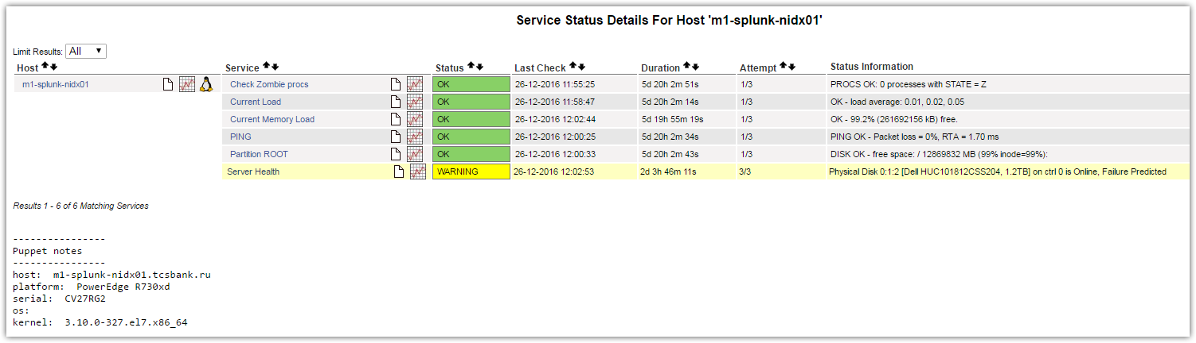
# We can get alert email from Dell.
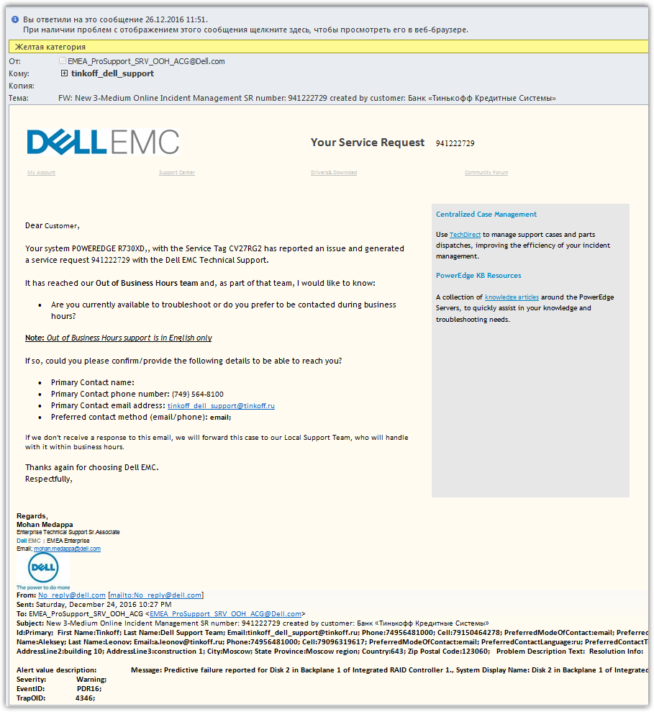

# In status of virtual disks we see nothing.
[root@m1-splunk-nidx01 ~]# racadm storage get vdisks -o -p layout,status
Disk.Virtual.0:RAID.Integrated.1-1
Layout = Raid-10
Status = Ok

[root@m1-splunk-nidx01 ~]#

# In status list of hard drives we see warning.
[root@m1-splunk-nidx01 ~]# racadm storage get pdisks -o -p status
Disk.Bay.0:Enclosure.Internal.0-1:RAID.Integrated.1-1
Status = Ok
Disk.Bay.1:Enclosure.Internal.0-1:RAID.Integrated.1-1
Status = Ok
Disk.Bay.2:Enclosure.Internal.0-1:RAID.Integrated.1-1
Status = Warning
Disk.Bay.3:Enclosure.Internal.0-1:RAID.Integrated.1-1
Status = Ok
...

# And in details of hard drive we can see warning and row about predicted failure.
[root@m1-splunk-nidx01 ~]# racadm storage get pdisks:Disk.Bay.2:Enclosure.Internal.0-1:RAID.Integrated.1-1
Disk.Bay.2:Enclosure.Internal.0-1:RAID.Integrated.1-1
Status = Warning
DeviceDescription = Disk 2 in Backplane 1 of Integrated RAID Controller 1
RollupStatus = Warning
Name = Physical Disk 0:1:2
State = Online
OperationState = Not Applicable
PowerStatus = Spun-Up
Size = 1117.25 GB
FailurePredicted = YES
RemainingRatedWriteEndurance = Not Applicable
SecurityStatus = Not Capable
BusProtocol = SAS
MediaType = HDD
UsedRaidDiskSpace = 1117.25 GB
AvailableRaidDiskSpace = 1117.25 GB
Hotspare = NO
Manufacturer = HGST
ProductId = HUC101812CSS204
Revision = FJ23
SerialNumber = 0EGJY8KD
PartNumber = TH09XNF6HGT006AK11V4A01
NegotiatedSpeed = 12.0 Gb/s
ManufacturedDay = 5
ManufacturedWeek = 43
ManufacturedYear = 2016
SasAddress = 0x5000CCA0801ECF59
FormFactor = 2.5 Inch
RaidNominalMediumRotationRate = 10000
T10PICapability = Not Capable
BlockSizeInBytes = 512
MaxCapableSpeed = 12 Gb/s
SelfEncryptingDriveCapability = Not Capable

[root@m1-splunk-nidx01 ~]#

# Get info about CPU.
[root@m1-pr-onlacq01 ~]# omreport chassis processors
Processors Information

Health : Ok

Index : 0
Status : Ok
Connector Name : CPU1
Processor Brand : Intel(R) Xeon(R) CPU E5-2630 v3 @ 2.40GHz
Processor Version : Model 63 Stepping 2
Current Speed : 2400 MHz
State : Present
Core Count : 8

Index : 1
Status : Ok
Connector Name : CPU2
Processor Brand : Intel(R) Xeon(R) CPU E5-2630 v3 @ 2.40GHz
Processor Version : Model 63 Stepping 2
Current Speed : 2400 MHz
State : Present
Core Count : 8

[root@m1-pr-onlacq01 ~]#

# Get info about network cards.
[root@ds-pr-onlacq01 ~]# omreport chassis nics
Network Interfaces Information

Physical NIC Interface(s)
Index : 0
Interface Name : em1
Vendor : Broadcom Corporation
Description : NetXtreme BCM5720 Gigabit Ethernet PCIe
Connection Status : Connected
Slot : Embedded

Index : 1
Interface Name : em2
Vendor : Broadcom Corporation
Description : NetXtreme BCM5720 Gigabit Ethernet PCIe
Connection Status : Connected
Slot : Embedded

Index : 2
Interface Name : em3
Vendor : Broadcom Corporation
Description : NetXtreme BCM5720 Gigabit Ethernet PCIe
Connection Status : Disabled
Slot : Embedded

Index : 3
Interface Name : em4
Vendor : Broadcom Corporation
Description : NetXtreme BCM5720 Gigabit Ethernet PCIe
Connection Status : Disabled
Slot : Embedded

Team Interface(s)
Index : 0
Interface Name : bond0
Vendor : Linux
Description : Ethernet Channel Bonding
Redundancy Status : Full

[root@ds-pr-onlacq01 ~]#

[root@ds-pr-onlacq01 ~]# omreport chassis -?

chassis Chassis component properties.

The available command(s) are:

Command Description
pwrmonitoring Power monitoring properties.
pwrmanagement Power management properties.
hwperformance Hardware performance information.
acswitch AC switch settings.
bios BIOS properties.
biossetup BIOS setup configuration properties.
bmc Remote Access information.
SUBCOMMAND DEPRECATION WARNING:
This subcommand is deprecated and will be discontinued in
a subsequent release.
Use the subcommand "remoteaccess" instead.
fans Fan probe(s) properties.
fru System Components (FRU) information.
leds Chassis LED settings.
firmware Firmware properties.
info Chassis information.
intrusion Chassis intrusion status.
memory System memory configuration.
nics Network interface card(s) and Team Interface(s) properties.
ports Port(s) properties.
frontpanel Front panel button control settings.
processors Processor(s) properties.
pwrsupplies Power supply(s) properties.
slots Slot(s) properties.
temps Temperature probe(s) properties.
volts Voltage probe(s) properties.
remoteaccess Remote Access information.
batteries Battery(s) properties.
removableflashmedia Removeable flash Media properties.

Usage: omreport <command...> [name=value...] ... [option...]

Valid command line options are:

-? Print available command(s) or command help.
-fmt <lst|tbl|ssv|cdv|xml> Format for output results, default is lst.
Where: lst List format.
tbl Table format.
ssv Semicolon separated format.
cdv Custom delimiter separated format.
xml Raw XML format.
-outc <file> Redirect output to file, delete old if exists.
OR
-outa <file> Redirect output to file, append to old if exists.
OR
Output may also be redirected using Operating System facilities (e.g. |more).

[root@ds-pr-onlacq01 ~]#

#
# 20200219
# A way to get info about free PCI-E slots.
# It helps to understand abilities to install additional NVME disks, for example.
#
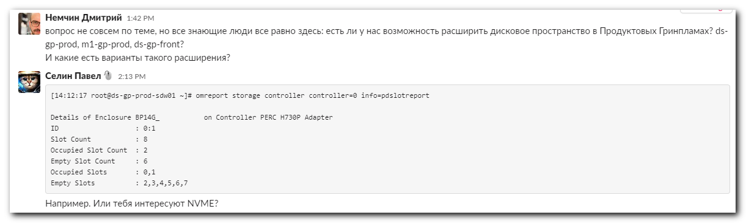

[14:53:23 root@ds-gp-prod-sdw01 ~]# omreport storage controller controller=0 info=pdslotreport

Details of Enclosure BP14G_ on Controller PERC H730P Adapter
ID : 0:1
Slot Count : 8
Occupied Slot Count : 2
Empty Slot Count : 6
Occupied Slots : 0,1
Empty Slots : 2,3,4,5,6,7

Occupied Physical Disk Details
ID : 0:1:0
Status : Ok
Name : Physical Disk 0:1:0
State : Online
Power Status : Not Applicable
Bus Protocol : SAS
Media : SSD
Part of Cache Pool : Not Applicable
Remaining Rated Write Endurance : 100%
Failure Predicted : No
Revision : DWL7
Driver Version : Not Applicable
Model Number : Not Applicable
T10 PI Capable : No
Certified : Yes
Encryption Capable : No
Encrypted : Not Applicable
Progress : Not Applicable
Mirror Set ID : Not Applicable
Capacity : 744.63 GB (799535005696 bytes)
Used RAID Disk Space : 744.63 GB (799535005696 bytes)
Available RAID Disk Space : 0.00 GB (0 bytes)
Hot Spare : No
Vendor ID : DELL(tm)
Product ID : MZILS800HEHP0D3
Serial No. : S3FVNX0K701207
Part Number : CN0HF06WSSX0087C013KA00
Negotiated Speed : 12.00 Gbps
Capable Speed : 12.00 Gbps
PCIe Negotiated Link Width : Not Applicable
PCIe Maximum Link Width : Not Applicable
Sector Size : 512B
Device Write Cache : Not Applicable
Manufacture Day : Not Available
Manufacture Week : 27
Manufacture Year : 2018
SAS Address : 5002538A4876A1D2
Non-RAID HDD Disk Cache Policy : Not Applicable
Disk Cache Policy : Not Applicable
Sub Vendor : Not Available
Available Spare : Not Available
Cryptographic Erase Capable : Yes

ID : 0:1:1
Status : Ok
Name : Physical Disk 0:1:1
State : Online
Power Status : Not Applicable
Bus Protocol : SAS
Media : SSD
Part of Cache Pool : Not Applicable
Remaining Rated Write Endurance : 100%
Failure Predicted : No
Revision : DWL7
Driver Version : Not Applicable
Model Number : Not Applicable
T10 PI Capable : No
Certified : Yes
Encryption Capable : No
Encrypted : Not Applicable
Progress : Not Applicable
Mirror Set ID : Not Applicable
Capacity : 744.63 GB (799535005696 bytes)
Used RAID Disk Space : 744.63 GB (799535005696 bytes)
Available RAID Disk Space : 0.00 GB (0 bytes)
Hot Spare : No
Vendor ID : DELL(tm)
Product ID : MZILS800HEHP0D3
Serial No. : S3FVNX0K701223
Part Number : CN0HF06WSSX0087C0142A00
Negotiated Speed : 12.00 Gbps
Capable Speed : 12.00 Gbps
PCIe Negotiated Link Width : Not Applicable
PCIe Maximum Link Width : Not Applicable
Sector Size : 512B
Device Write Cache : Not Applicable
Manufacture Day : Not Available
Manufacture Week : 27
Manufacture Year : 2018
SAS Address : 5002538A4876A2D2
Non-RAID HDD Disk Cache Policy : Not Applicable
Disk Cache Policy : Not Applicable
Sub Vendor : Not Available
Available Spare : Not Available
Cryptographic Erase Capable : Yes

[14:54:57 root@ds-gp-prod-sdw01 ~]#

20160406
# Below is a experience of how to not to do.
# Here I have created joqueue to apply some changes, but I have used one key, that imedietly start reboot server!
#
# !!! After this option "-r pwrcycle" server starts REBOOT.
# The server doesn't wait until it will be rebooted. It starts reboot imedietely.
#
racadm>>set bios.IntegratedDevices.UsbPorts AllOff

racadm set bios.IntegratedDevices.UsbPorts AllOff
[Key=BIOS.Setup.1-1#IntegratedDevices]
RAC1017: Successfully modified the object value and the change is in
pending state.
To apply modified value, create a configuration job and reboot
the system. To create the commit and reboot jobs, use "jobqueue"
command. For more information about the "jobqueue" command, see RACADM
help.

racadm>>

racadm>>get bios.IntegratedDevices.UsbPorts

racadm get bios.IntegratedDevices.UsbPorts
[Key=BIOS.Setup.1-1#IntegratedDevices]
UsbPorts=AllOn (Pending Value=AllOff)

racadm>>

racadm>>jobqueue create BIOS.Setup.1-1 -r pwrcycle

racadm jobqueue create BIOS.Setup.1-1 -r pwrcycle
RAC1024: Successfully scheduled a job.
Verify the job status using "racadm jobqueue view -i JID_xxxxx" command.
Commit JID = JID_597847944208
Reboot JID = RID_597847946200

racadm>>

# This job looks like follow.
racadm>>jobqueue view
...
----------------------------------------------------------
[Job ID=RID_597847946200]
Job Name=Reboot: Power cycle
Status=Reboot Completed
Start Time=[Now]
Expiration Time=[Not Applicable]
Message=[RED030: Reboot is complete.]
Percent Complete=[NA]
----------------------------------------------------------

racadm>>

# After unexpected reboot. Required option is set.
#
racadm>>get bios.IntegratedDevices.UsbPorts

racadm get bios.IntegratedDevices.UsbPorts
[Key=BIOS.Setup.1-1#IntegratedDevices]
UsbPorts=AllOff

racadm>>

# This way should be used to create job.
# After this, server is not rebooting. It’s waiting for when we will command to reboot.
racadm>>jobqueue create BIOS.Setup.1-1
racadm jobqueue create BIOS.Setup.1-1
RAC1024: Successfully scheduled a job.
Verify the job status using "racadm jobqueue view -i JID_xxxxx" command.
Commit JID = JID_597841280716
racadm>>

http://www.dell.com/support/manuals/us/en/19/poweredge-r730xd/iDRAC_RACADM_Pub/jobqueue?guid=GUID-F9C9CD97-B586-4FB9-95F5-B33FEA44C71D&lang=en-us

jobqueue
Description | Enables you to view and delete a job or jobs in the current Job Queue.  - NOTE:  - To run this subcommand, you must have the Server control privilege.  - If an unexpected error message is displayed for any operation, ensure you delete some jobs in the jobqueue and retry the operation.
Synopsis | racadm jobqueue view -i<jobid>  racadm jobqueue delete [-i<jobid>][--all]  where valid options are -i and --all.  racadm jobqueue create <fqdd> [-r <reboot type> ] [-s <start time> ] [-e <expiry time>]  racadm jobqueue create <fqdd> [-r <reboot type>] [-s <start time>] [-e <expiration time>] [--realtime]

Input | - -i — Specifies a job ID that is displayed or deleted.  - NOTE: The value JID_CLEARALL will force delete all the possible jobs in the queue.  - --all — The job IDs that are not applicable are deleted.  - -fqdd — Specifies an FQDD for which a job should be created.  - —r <reboot type> — Specifies a reboot type.  - none — No Reboot Job. This option is the default value.  - pwrcycle — Power cycle.  - graceful — Graceful Reboot without forced shut down.  - forced — Graceful Reboot with forced shut down.  - start time — Specifies a start time for job scheduled in the yyyymmddhhmmss format. TIME_NOW means immediate. Next Reboot means job is in scheduled state until the next manual restart.  - expiry time — Specifies expiry time for the job execution in the yyyymmddhhmmss format. The job must start by this time. TIME_NA means expiry time is not applicable.  - --realtime — Specifies the real time job.  - NOTE:  - --realtime is applicable for storage configuration commands run on systems with PERC 9 cards with firmware version 9.1 and later.  - -r option is not valid for real time configuration.

20160419
# Command to reboot (reload) iDRAC.

[root@ds-hadoop-wk14p ~]# racadm racreset hard
RAC reset operation initiated successfully. It may take a few
minutes for the RAC to come online again.

[root@ds-hadoop-wk14p ~]#

http://www.gnali.org/?p=435

iDRAC 7 CheatSheet
Filed under: Day to day sys administration — Tags: dell, idrac, racadm — Tin' @ 3:11 pm
# Get all iDRAC settings in a file
?
1 | racadm get -f config.txt
# Set password for root user
?
1 | racadm set iDRAC.Users.2.Password "password"
# List all ssh key for root user
?
1 | racadm sshpkauth -i 2 -v -k all
# Add ssh key to root user
?
1 | racadm sshpkauth -i 2 -k 1 "contents of the public key file"
# Delete ssh key for root user
?
1 | racadm sshpkauth -i 2 -d -k 1
# Get iDRAC IP config
?
1  2 | racadm getniccfg  racadm get iDRAC.NIC
# Set iDRAC DNS Name
?
1 | racadm set iDRAC.NIC.DNSRacName rougerie-rsc
# Set iDRAC domain Name
?
1 | racadm set iDRAC.NIC.DNSDomainName gnali.org
# Set iDRAC DNS server
?
1  2 | racadm config -g cfgLanNetworking -o cfgDNSServer1 191.254.31.175  racadm config -g cfgLanNetworking -o cfgDNSServer2 184.7.12.44
## Set FrontLCD to hostname
?
1 | racadm set System.LCD.Configuration 16
# Reset iDRAC to factory defaults
?
1 | racadm racresetcfg
#Reset iDRAC
?
1 | racadm racreset
# Get serial number (service tag)
?
1 | racadm getsvctag
# Get current system information
?
1 | racadm getsysinfo
# Configure One-Time-Boot
?
1  2 | racadm set BIOS.OneTimeBoot.OneTimeBootMode OneTimeBootSeq  racadm set BIOS.OneTimeBoot.OneTimeBootSeqDev NIC.Integrated.1-1-1
# Create Commit and Reboot jobqueue to apply BIOS or NIC Configuration
?
1 | racadm jobqueue create BIOS.Setup.1-1 -r pwrcycle -s TIME_NOW -e TIME_NA
# Create Commit jobqueue without Reboot
?
1 | racadm jobqueue create BIOS.Setup.1-1
# Delete a jobqueue
?
1 | racadm jobqueue delete -i &lt;job_ID&gt;
# List all Jobqueue
?
1 | racadm jobqueue view
# Check Boot Order List
?
1 | racadm get BIOS.BiosBootSettings.bootseq
# Disable HyperThreadings
?
1 | racadm set BIOS.ProcSettings.LogicalProc Disabled
# Disabled OS to iDRAC Pass-through for iDRAC Service Module (automatically create a pseudo NIC in OS)
?
1 | racadm set iDRAC.OS-BMC.AdminState Disabled
# Change SNMP public community
?
1 | racadm set iDRAC.SNMP.AgentCommunity unixplop
# Disable ASR
?
1 | racadm config -g cfgRacTuning -o cfgRacTuneAsrEnable 0
# Configure Serial redirection
?
1  2  3  4  5 | racadm config -g cfgSerial -o cfgSerialConsoleEnable 1  racadm config -g cfgSerial -o cfgSerialBaudRate 115200  racadm config -g cfgSerial -o cfgSerialCom2RedirEnable 1  racadm config -g cfgSerial -o cfgSerialTelnetEnable 0  racadm config -g cfgSerial -o cfgSerialSshEnable 1
# Access ssh console
?
1  2 | ssh root@rouerie-rsc  console com2
# Disable Serial On Lan
?
1 | racadm config -g cfgIpmiSol -o cfgIpmiSolEnable 0
# Help on specific section
?
1 | racadm help BIOS.SysProfileSettings
# Change Power Profile
?
1 | racadm set BIOS.SysProfileSettings PerfPerWattOptimizedOs
# Set AC Power Recovery
?
1  2 | racadm set BIOS.SysSecurity.AcPwrRcvry Last  racadm set BIOS.SysSecurity.AcPwrRcvryDelay Immediate
# Get RAID physical Disk information
?
1  2  3 | racadm raid get pdisks  racadm raid get pdisks -o (all information)  racadm raid get pdisks -o -p state,size (specific information)
# Get RAID Virtual Disk Information
?
1 | racadm raid get vdisks
# Configuration Web Virtual console to use JAVA

http://virtual-grind.com/2012/10/09/restarting-drac-interface/
9OCT/120
I recently ran in to a few situations where the DRAC web interface was acting funny.
In one event, when I would log in to the DRAC web interface, despite having the correct username and password, the web interface would just bring me back to the main login page. The second scenario would let me in the main DRAC admin page, but I could not launch a remote console.
Anyway, there is a very simple fix. Simply ssh into your DRAC ip address with the same username and password you use to access the web interface. Once you ssh in, you will be at the main DRAC admin prompt. To reset DRAC and NOT lose any settings, simply enter the command:
racadm racreset sof

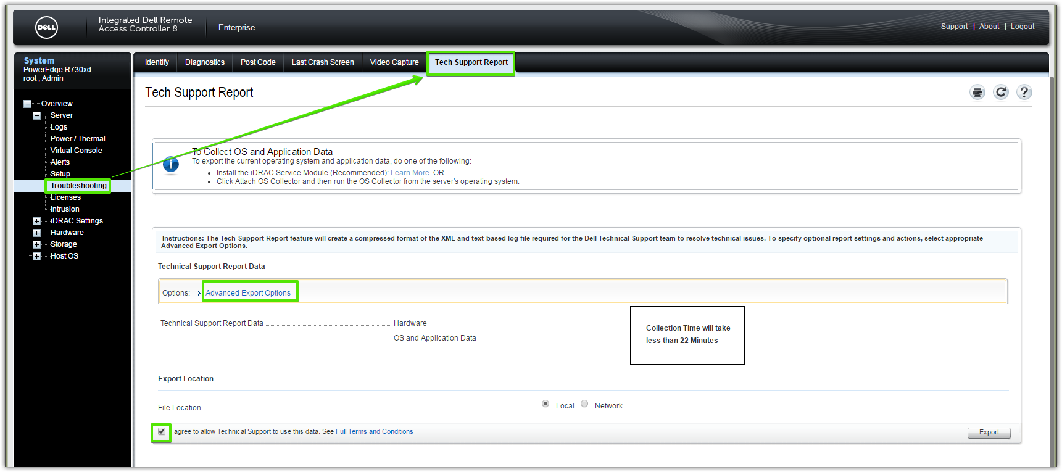

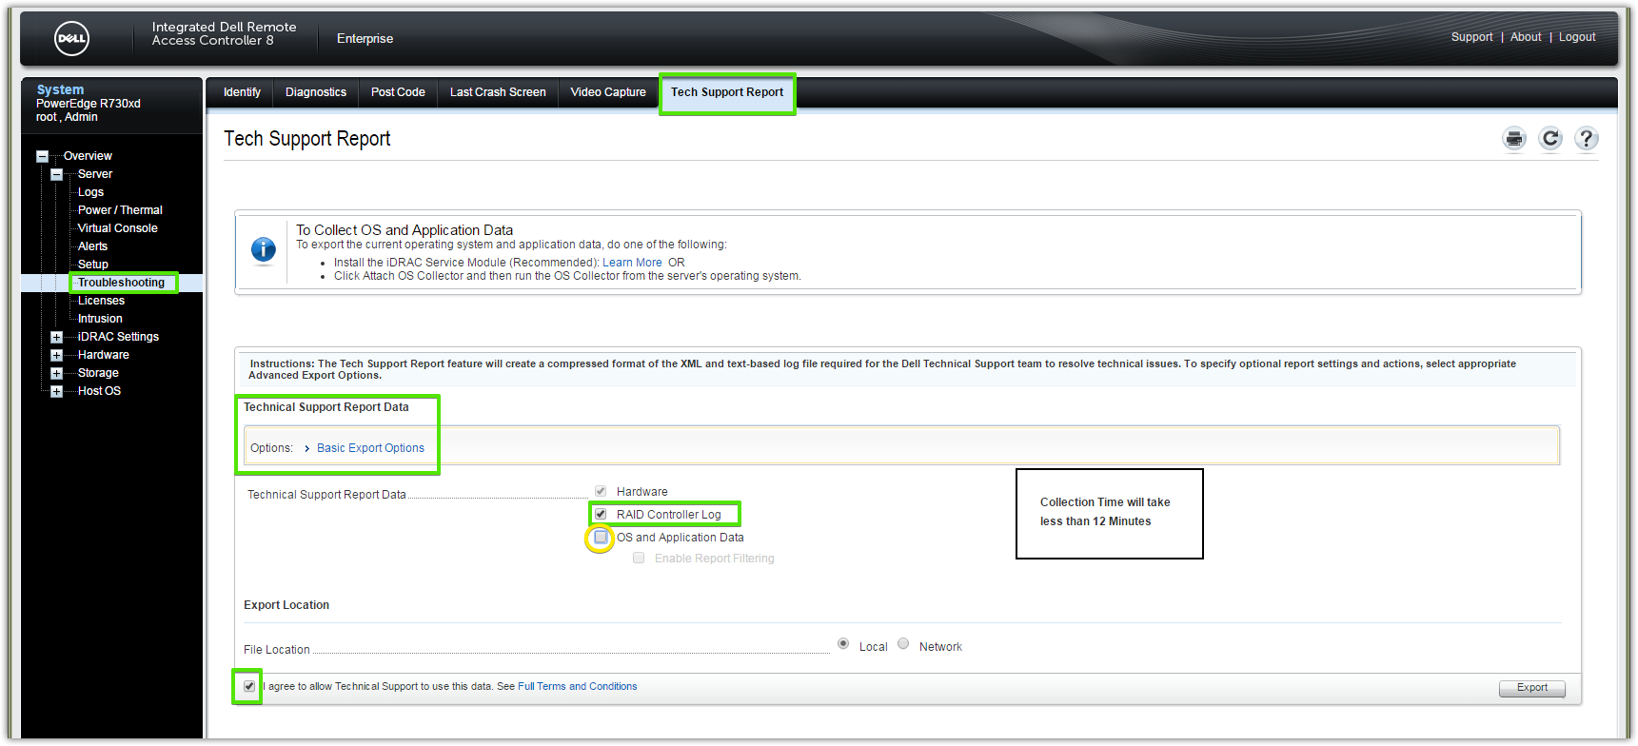

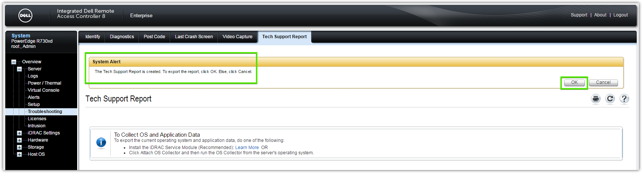

20160824
# How to find mount point that used to hard drive or vice versa.

root@ds-gp-prd-sdw17 ~]# racadm storage get vdisks -o -p layout,status && racadm storage get controllers -o -p Status,DeviceDescription,Name
Disk.Virtual.0:RAID.Integrated.1-1
Layout = Raid-1
Status = Ok
Disk.Virtual.1:RAID.Integrated.1-1
Layout = Raid-10
Status = Ok
Disk.Virtual.0:RAID.Slot.3-1
Layout = Raid-10
Status = Ok

RAID.Integrated.1-1
Status = Ok
DeviceDescription = Integrated RAID Controller 1
Name = PERC H730P Mini (Embedded)
RAID.Slot.3-1
Status = Ok
DeviceDescription = RAID Controller in Slot 3
Name = PERC H730P Adapter (PCI Slot 3)
AHCI.Embedded.1-1
Status = Unknown
DeviceDescription = Embedded AHCI 1
Name = C610/X99 series chipset sSATA Controller [AHCI mode] (Embedded)
AHCI.Embedded.2-1
Status = Unknown
DeviceDescription = Embedded AHCI 2
Name = C610/X99 series chipset 6-Port SATA Controller [AHCI mode] (Embedded)

[root@ds-gp-prd-sdw17 ~]#

#
# Now we know, "RAID.Slot.3-1" has "Name"="PERC H730P Adapter (PCI Slot 3)".
#

# We remember, that problem disk has identification: Disk.Bay.19:Enclosure.Internal.0-1:RAID.Slot.3-1.
# That means, that this disk is placed on "PERC H730P Adapter (PCI Slot 3)".
#
# Then we define, that "PERC H730P Adapter (PCI Slot 3)" has block device "/dev/sdc".
#
[root@ds-gp-prd-sdw13 ~]# lsscsi -g
[0:2:0:0] disk DELL PERC H730P Mini 4.26 /dev/sda /dev/sg0
[0:2:1:0] disk DELL PERC H730P Mini 4.26 /dev/sdb /dev/sg1
[1:2:0:0] disk DELL PERC H730P Adp 4.26 /dev/sdc /dev/sg2
[root@ds-gp-prd-sdw13 ~]#

# Here we can see, that the block device "/dev/sdc" mounted to "/data2" mount point.
#
[root@ds-gp-prd-sdw13 ~]# lsblk
NAME MAJ:MIN RM SIZE RO TYPE MOUNTPOINT
nvme0n1 259:0 0 1.5T 0 disk /ssd1
sda 8:0 0 558.4G 0 disk
├─sda1 8:1 0 1G 0 part /boot
├─sda2 8:2 0 6G 0 part [SWAP]
├─sda3 8:3 0 251.4G 0 part /
├─sda4 8:4 0 1K 0 part
└─sda5 8:5 0 300G 0 part /duet
sdc 8:32 0 2.2T 0 disk
└─sdc1 8:33 0 2.2T 0 part /data2
sdb 8:16 0 2.2T 0 disk
└─sdb1 8:17 0 2.2T 0 part /data1
[root@ds-gp-prd-sdw13 ~]#

# Now we know, that disk "Disk.Bay.19:Enclosure.Internal.0-1:RAID.Slot.3-1" belong to mount point "/data2".

# How to get details about defined raid controller.
[root@ds-gp-prd-sdw13 ~]# racadm storage get controllers:RAID.Integrated.1-1 -p Status,DeviceDescription,Name,SlotType
RAID.Integrated.1-1
Status = Ok
DeviceDescription = Integrated RAID Controller 1
Name = PERC H730P Mini (Embedded)
SlotType = Unknown

[root@ds-gp-prd-sdw13 ~]#

# For PCI-E cards we can get info, where it placed.
[root@ds-gp-prd-sdw13 ~]# racadm storage get controllers:RAID.Slot.3-1 -p Status,DeviceDescription,Name,PciSlot,SlotType
RAID.Slot.3-1
Status = Ok
DeviceDescription = RAID Controller in Slot 3
Name = PERC H730P Adapter (PCI Slot 3)
PciSlot = 3
SlotType = PCI Express Gen3 x16

[root@ds-gp-prd-sdw13 ~]#
k
[root@ds-gp-prd-sdw13 ~]# racadm storage get controllers -o
...
RAID.Slot.3-1
Status = Ok
DeviceDescription = RAID Controller in Slot 3
RollupStatus = Ok
Name = PERC H730P Adapter (PCI Slot 3)
PciSlot = 3
FirmwareVersion = 25.4.0.0017
DriverVersion = --NA--
RebuildRate = 30
BgiRate = 30
CheckConsistencyRate = 30
ReconstructRate = 30
PatrolReadRate = 30
PatrolReadMode = Automatic
PatrolReadState = Stopped
CheckConsistencyMode = Normal
LoadBalanceSetting = Auto
CopybackMode = ON
PreservedCache = Not Present
CacheMemorySize = 2048 MB
PersistHotspare = Disabled
SpindownUnconfiguredDrives = Disabled
SpindownHotspare = Disabled
Timeintervalforspindown = 30 (Minutes)
SecurityStatus = Encryption Capable
EncryptionMode = None
SasAddress = 0x544A842031B8D200
PciDeviceId = 0x5d
PciSubdeviceId = 0x1f42
PciVendorId = 0x1000
PciSubvendorId = 0x1028
PciBus = 0x32
PciDevice = 0x0
PciFunction = 0x0
BusWidth = 8x or x8
SlotLength = Long Length
SlotType = PCI Express Gen3 x16
MaxCapableSpeed = 12.0 Gb/s
LearnMode = Not supported
T10PIC apability = Capable
SupportRAID10UnevenSpans = Supported
SupportEnhancedAutoForeignImport = Supported
EnhancedAutoImportForeignConfig = Disabled
SupportControllerBootMode = Supported
ControllerBootMode = Continue Boot On Error
RealtimeConfigurationCapability = Capable
CurrentControllerMode = RAID

# Here is how to see some details about disk
[root@ds-gp-prd-sdw13 ~]# racadm storage get pdisks:Disk.Bay.19:Enclosure.Internal.0-1:RAID.Slot.3-1

[root@ds-gp-prd-sdw13 ~]# lspci -v | less
...
02:00.0 RAID bus controller: LSI Logic / Symbios Logic MegaRAID SAS-3 3108 [Invader] (rev 02)
Subsystem: Dell PERC H730P Mini
Flags: bus master, fast devsel, latency 0, IRQ 26
I/O ports at 2000 [size=256]
Memory at 96300000 (64-bit, non-prefetchable) [size=64K]
Memory at 96200000 (64-bit, non-prefetchable) [size=1M]
Expansion ROM at 91a00000 [disabled] [size=1M]
Capabilities: [50] Power Management version 3
Capabilities: [68] Express Endpoint, MSI 00
Capabilities: [d0] Vital Product Data
Capabilities: [a8] MSI: Enable- Count=1/1 Maskable+ 64bit+
Capabilities: [c0] MSI-X: Enable+ Count=97 Masked-
Capabilities: [100] Advanced Error Reporting
Capabilities: [1e0] #19
Capabilities: [1c0] Power Budgeting <?>
Capabilities: [148] Alternative Routing-ID Interpretation (ARI)
Kernel driver in use: megaraid_sas
Kernel modules: megaraid_sas
...
84:00.0 RAID bus controller: LSI Logic / Symbios Logic MegaRAID SAS-3 3108 [Invader] (rev 02)
Subsystem: Dell PERC H730P Adapter
Flags: bus master, fast devsel, latency 0, IRQ 64
I/O ports at 8000 [size=256]
Memory at c8100000 (64-bit, non-prefetchable) [size=64K]
Memory at c8000000 (64-bit, non-prefetchable) [size=1M]
Expansion ROM at c8300000 [disabled] [size=1M]
Capabilities: [50] Power Management version 3
Capabilities: [68] Express Endpoint, MSI 00
Capabilities: [d0] Vital Product Data
Capabilities: [a8] MSI: Enable- Count=1/1 Maskable+ 64bit+
Capabilities: [c0] MSI-X: Enable+ Count=97 Masked-
Capabilities: [100] Advanced Error Reporting
Capabilities: [1e0] #19
Capabilities: [1c0] Power Budgeting <?>
Capabilities: [148] Alternative Routing-ID Interpretation (ARI)
Kernel driver in use: megaraid_sas
Kernel modules: megaraid_sas

#
# 20171102
#
# Some commands to get info about drives.

[root@ds-hadoop-wk10p ~]# omreport storage vdisk
List of Virtual Disks in the System

Controller PERC H730P Mini (Embedded)
ID : 0
Status : Ok
Name : Virtual Disk 0
State : Ready
Hot Spare Policy violated : Not Assigned
Encrypted : Not Applicable
Layout : RAID-1
Size : 465.25 GB (499558383616 bytes)
T10 Protection Information Status : No
Associated Fluid Cache State : Not Applicable
Device Name : /dev/sdm
Bus Protocol : SAS
Media : HDD
Read Policy : Read Ahead
Write Policy : Write Back
Cache Policy : Not Applicable
Stripe Element Size : 64 KB
Disk Cache Policy : Unchanged

[root@ds-hadoop-wk10p ~]#

[root@ds-hadoop-wk10p ~]# omreport storage pdisk controller=0
List of Physical Disks on Controller PERC H730P Mini (Embedded)

Controller PERC H730P Mini (Embedded)
ID : 0:1:0
Status : Ok
Name : Physical Disk 0:1:0
State : Non-RAID
Power Status : Spun Up
Bus Protocol : SAS
Media : HDD
Part of Cache Pool : Not Applicable
Remaining Rated Write Endurance : Not Applicable
Failure Predicted : No
Revision : GS11
Driver Version : Not Applicable
Model Number : Not Applicable
T10 PI Capable : No
Certified : Yes
Encryption Capable : No
Encrypted : Not Applicable
Progress : Not Applicable
Mirror Set ID : Not Applicable
Capacity : 3,725.50 GB (4000225165312 bytes)
Used RAID Disk Space : 0.00 GB (0 bytes)
Available RAID Disk Space : 3,725.50 GB (4000225165312 bytes)
Hot Spare : No
Vendor ID : DELL(tm)
Product ID : ST4000NM0023
Serial No. : Z1Z5QE85
Part Number : TH0529FG2123349B06EKA02
Negotiated Speed : 6.00 Gbps
Capable Speed : 6.00 Gbps
PCIe Negotiated Link Width : Not Applicable
PCIe Maximum Link Width : Not Applicable
Sector Size : 512B
Device Write Cache : Not Applicable
Manufacture Day : 07
Manufacture Week : 37
Manufacture Year : 2014
SAS Address : 5000C500626E25DD
Form Factor : Not Available
Sub Vendor : Not Available

…

ID : 0:1:13
Status : Non-Critical
Name : Physical Disk 0:1:13
State : Online
Power Status : Spun Up
Bus Protocol : SAS
Media : HDD
Part of Cache Pool : Not Applicable
Remaining Rated Write Endurance : Not Applicable
Failure Predicted : Yes
Revision : AS0B
Driver Version : Not Applicable
Model Number : Not Applicable
T10 PI Capable : No
Certified : Yes
Encryption Capable : No
Encrypted : Not Applicable
Progress : Not Applicable
Mirror Set ID : Not Applicable
Capacity : 465.25 GB (499558383616 bytes)
Used RAID Disk Space : 465.25 GB (499558383616 bytes)
Available RAID Disk Space : 0.00 GB (0 bytes)
Hot Spare : No
Vendor ID : DELL(tm)
Product ID : ST9500620SS
Serial No. : 9XF3KW1L
Part Number : TH055RMX2123354600Q4A08
Negotiated Speed : 6.00 Gbps
Capable Speed : 6.00 Gbps
PCIe Negotiated Link Width : Not Applicable
PCIe Maximum Link Width : Not Applicable
Sector Size : 512B
Device Write Cache : Not Applicable
Manufacture Day : 04
Manufacture Week : 15
Manufacture Year : 2015
SAS Address : 5000C5008378DA15
Form Factor : Not Available
Sub Vendor : Not Available

[root@ds-hadoop-wk10p ~]#
# One drive above is in Predictive failure state, by the way.

20160824
# How to highlight drives at server and server too.

[root@ds-gp-prd-sdw17 ~]# at 18:00 today <<< 'racadm storage blink:Disk.Bay.2:Enclosure.Internal.0-1:RAID.Integrated.1-1'
job 1 at 2016-08-23 18:00
[root@ds-gp-prd-sdw17 ~]# at 18:00 today <<< 'racadm storage blink:Disk.Bay.15:Enclosure.Internal.0-1:RAID.Slot.3-1'
job 2 at 2016-08-23 18:00
[root@ds-gp-prd-sdw17 ~]# logout

[root@ds-gp-prd-sdw13 ~]# at 18:00 today <<< 'racadm storage blink:Disk.Bay.19:Enclosure.Internal.0-1:RAID.Slot.3-1'
job 1 at 2016-08-23 18:00
[root@ds-gp-prd-sdw13 ~]#

[root@ds-gp-prd-sdw13 ~]# at 18:00 today <<< 'racadm setled -l 1'
job 2 at 2016-08-23 18:00
[root@ds-gp-prd-sdw13 ~]# logout
Connection to sdw13 closed.
[root@ds-gp-prd-smdw ~]# ssh sdw17
Last login: Tue Aug 23 17:00:13 2016 from mdw
[root@ds-gp-prd-sdw17 ~]# at 18:00 today <<< 'racadm setled -l 1'
job 3 at 2016-08-23 18:00
[root@ds-gp-prd-sdw17 ~]#

20160824
# This is attempt to do some check on drives or whole raid controller.

From: Vladimir_Markus@dell.com [mailto:Vladimir_Markus@dell.com]
Sent: Friday, August 19, 2016 5:55 PM
To: Belogrud Sergey Vladimirovich
Cc: Piotr_Kretkiewicz@Dell.com
Subject: RE: Dell Support Case: 932140477 [R730xd] HDDs performance down

Dell - Internal Use - Confidential
Добрый день, Сергей,

Если мне не изменяет память, то тест занимает несколько часов и проводится как background operation.
...
Документ, по которому не работала ссылка прилагаю, но можете запустить чек через команду racadm.

Mit freundlichen Grüßen / Best Regards / С уважением
Vladimir Markus
Enterprise Resolution Manager

From: Vladimir_Markus@dell.com [mailto:Vladimir_Markus@dell.com]
Sent: Friday, August 19, 2016 1:18 PM
To: Belogrud Sergey Vladimirovich
Cc: Leonov Aleksey Vladimirovich; Piotr_Kretkiewicz@Dell.com
Subject: RE: Dell Support Case: 932140477 [R730xd] HDDs performance down
...
Consistency Check можно запустить через OMSA в WebGUI, racadm с помощию команды- racadm storage ccheck:<vdisk fqdd> или PERC CLI (инструкция на странице 42 в мануале - https://topics-cdn.dell.com/pdf/poweredge-rc-h730_Reference%20Guide_en-us.pdf )

Mit freundlichen Grüßen / Best Regards / С уважением
Vladimir Markus
Enterprise Resolution Manager

From: Vladimir_Markus@dell.com [mailto:Vladimir_Markus@dell.com]
Sent: Friday, August 19, 2016 12:13 PM
To: Leonov Aleksey Vladimirovich; Piotr_Kretkiewicz@Dell.com
Cc: Belogrud Sergey Vladimirovich
Subject: RE: Dell Support Case: 932140477 [R730xd] HDDs performance down
...
Заказы мы оформили, в понедельник диски должны быть у Вас. Наши коллеги L3 попросили еще запустить Consistency Check до и после замены дисков.

Mit freundlichen Grüßen / Best Regards / С уважением
Vladimir Markus
Enterprise Resolution Manager

[root@ds-gp-prd-sdw13 ~]# racadm raid ccheck:Disk.Virtual.0:RAID.Slot.3-1
STOR094 : The storage configuration operation is successfully completed
and the change is in pending state.
To apply the configuration operation immediately, create a configuration job
using the --realtime option.
To apply the configuration after restarting
the server, create a configuration job using the -r option.
To create the necessary real-time and restart jobs, run the jobqueue command.
For more information about jobqueue command, run the
'racadm help jobqueue' command.

[root@ds-gp-prd-sdw13 ~]#

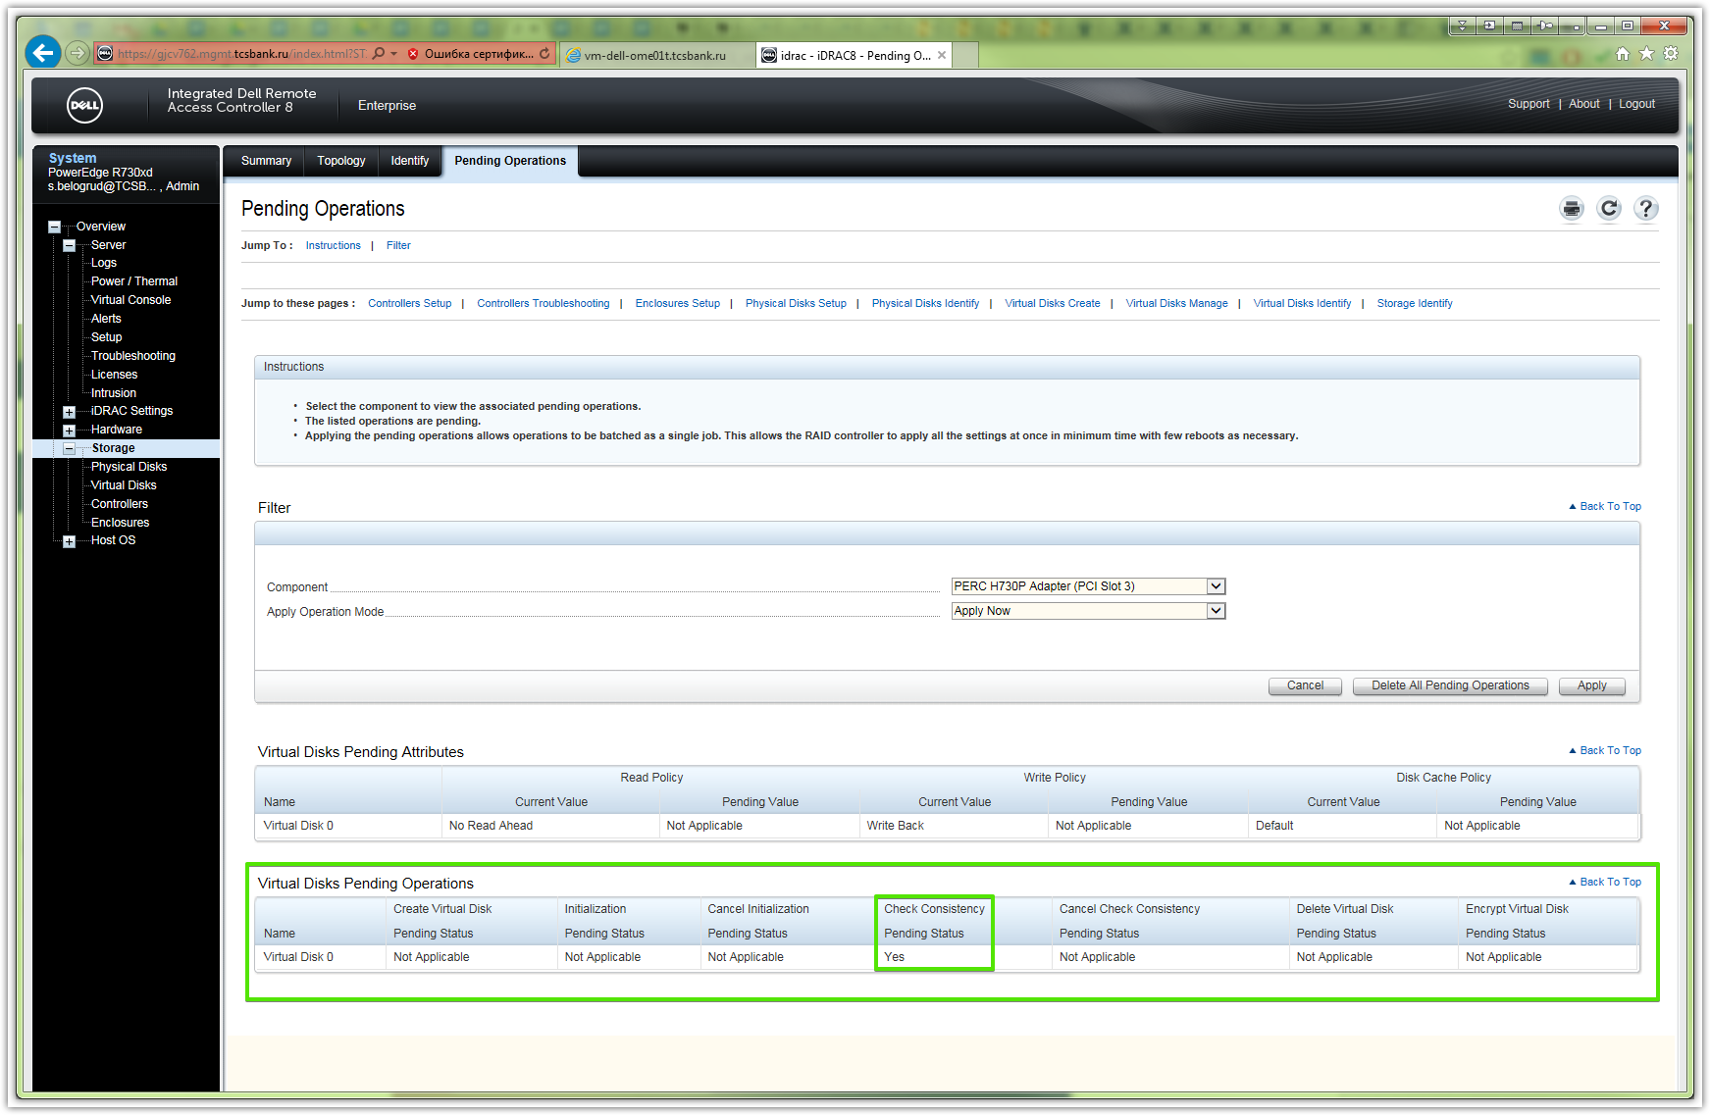

20161003
# Change default root password for iDRAC.

# This command line allow insert ip-address (10.219.11.101) or fqdn 488v762.mgmt.tcsbank.ru) of idrac interface.
[support@centos00 20161003-1206]$ while read -p "Enter iDRAC FQDN: " var1_servicetag ; do var2_username="$( SSHPASS="$(pass common/windows-current)" sshpass -e ssh -t -oStrictHostKeyChecking=no tcsbank.ru\\s.belogrud@${var1_servicetag} racadm get idrac.users.2.username | grep UserName | cut -d "=" -f2 | tr -d '\r' )" ; if [ "${var2_username}" = "root" ] ; then echo -e "Server: ${var1_servicetag}\nUser: ${var2_username}" ; var3_newpassword="$(pwgen -c -n -s -C 10 1)" ; echo "Password: ${var3_newpassword}" ; SSHPASS="$(pass common/windows-current)" sshpass -e ssh -t -oStrictHostKeyChecking=no tcsbank.ru\\s.belogrud@${var1_servicetag} racadm set idrac.users.2.password "${var3_newpassword}" | tee -a ./$(date +%Y%m%d-%H%M).racadm.set.${var1_servicetag}.txt ; else echo "No, we mightn't change pasword for user: ${var2_username}." ; fi ; done
Enter iDRAC FQDN: 10.219.11.101
Warning: Permanently added '10.219.11.101' (RSA) to the list of known hosts.
Connection to 10.219.11.101 closed.
Server: 10.219.11.101
User: root
Password: h9NOr8ZS7r
[Key=idrac.Embedded.1#Users.2]
Object value modified successfully
Connection to 10.219.11.101 closed.
Enter iDRAC FQDN: 10.219.10.223
Warning: Permanently added '10.219.10.223' (RSA) to the list of known hosts.
Connection to 10.219.10.223 closed.
Server: 10.219.10.223
User: root
Password: KixNk9EoRa
[Key=idrac.Embedded.1#Users.2]
Object value modified successfully
Connection to 10.219.10.223 closed.
Enter iDRAC FQDN: ^C
[support@centos00 20161003-1206]$

# Here we can insert only Service tag.
[support@centos00 20161003-1206]$ while read -p "Enter service tag: " var1_servicetag ; do var2_username="$( SSHPASS="$(pass common/windows-current)" sshpass -e ssh -t -oStrictHostKeyChecking=no tcsbank.ru\\s.belogrud@${var1_servicetag}.mgmt.tcsbank.ru racadm get idrac.users.2.username | grep UserName | cut -d "=" -f2 | tr -d '\r' )" ; if [ "${var2_username}" = "root" ] ; then echo -e "Service tag: ${var1_servicetag}\nServer: ${var1_servicetag}.mgmt.tcsbank.ru\nUser: ${var2_username}" ; var3_newpassword="$(pwgen -c -n -s -C 10 1)" ; echo "Password: ${var3_newpassword}" ; SSHPASS="$(pass common/windows-current)" sshpass -e ssh -t -oStrictHostKeyChecking=no tcsbank.ru\\s.belogrud@${var1_servicetag}.mgmt.tcsbank.ru racadm set idrac.users.2.password "${var3_newpassword}" | tee -a ./$(date +%Y%m%d-%H%M).racadm.set.${var1_servicetag}.txt ; else echo "No, we mightn't change pasword for user: ${var2_username}." ; fi ; done
Enter service tag: 5VJL8D2
Warning: Permanently added '5vjl8d2.mgmt.tcsbank.ru,10.219.9.109' (RSA) to the list of known hosts.
Connection to 5VJL8D2.mgmt.tcsbank.ru closed.
Service tag: 5VJL8D2
Server: 5VJL8D2.mgmt.tcsbank.ru
User: root
Password: KB8Qawnwtm
[Key=idrac.Embedded.1#Users.2]
Object value modified successfully
Connection to 5VJL8D2.mgmt.tcsbank.ru closed.
...

From: Leonov Aleksey Vladimirovich
Sent: Friday, January 13, 2017 11:06 AM
To: Belogrud Sergey Vladimirovich
Subject: RE: dell srvadmin sudden segfault

на m1-arc-manager01

в нагиос выглядело как отвал Server Health по snmp.

Алексей Леонов
Администратор серверных комплексов
Тел.: +7 495 648-10-00, доб. 2536

From: Belogrud Sergey Vladimirovich
Sent: Friday, January 13, 2017 10:55 AM
To: Leonov Aleksey Vladimirovich
Subject: RE: dell srvadmin sudden segfault

Добрый день.

А это на где так стало?
И как оно себя предъявляло в виде ошибок? От nagios что-то сыпалось?

Сергей Белогруд
Старший системный администратор
Тел.: +7 495 648-10-00, доб. 2173

From: Leonov Aleksey Vladimirovich
Sent: Friday, January 13, 2017 9:27 AM
To: unix-admins
Subject: dell srvadmin sudden segfault

Доброго времени суток, Коллеги.

как говорится, я просто оставлю это здесь:

симптом:
OMSA, всех мастей, внезапно начинает сегфолтится.

вся проблема в семафорах. их кончилось. надо увеличить:

sysctl -w kernel.sem="250 32000 100 1184"

и в /etc/sysctl.conf
kernel.sem=250 32000 100 1184

ну и рестарт служб.

все сразу начнет работать

С уважением,

Алексей Леонов
Администратор серверных комплексов

From: Piotr.Kretkiewicz@dell.com [mailto:Piotr.Kretkiewicz@dell.com]
Sent: Wednesday, February 01, 2017 12:01 PM
To: Leonov Aleksey Vladimirovich; Belogrud Sergey Vladimirovich
Subject: RE: Dell Support Case: 942816195 [R730xd]

Добрый день,

Конечно Вам заменим, но если я бы сразу получил логи из контроллера жестких дисков, может я бы раньше нашел информацию о сбое этого диска.
У меня вопрос: потому что не очень есть отправлять запчасти два раза за одну неделю на данном сервис таге, могу я Вам выписать вызов в пятницу?
Это помогло бы избежать сложностей

Кроме того, высылаю Вам ссылку на утилиту которая собирает только логи контроллера RAID. Может в случаях когда вылетает диск, Вам будет проще чем собирать TSR

Extracting the RAID-Controller Logs via MegaCLI (Windows + Linux)

Прямая ссылка на скачивание megacli:
http://www.avagotech.com/docs-and-downloads/raid-controllers/raid-controllers-common-files/8-07-14_MegaCLI.zip

To export information about the status of the RAID controller and the connected hard drives, use the MegaCLI tool by LSI.

Note: This article is aimed at Dell PowerEdge servers with the following operating systems:
· Windows (Windows Server 2003/2008/2012)
· Linux (SLES, RHEL, XenServer, other distributions)

To create the appropriate diagnostic files, perform the following steps:
1. Download the appropriate version of the MegaCli tool for Windows Operating systems from the Download section of the LSI support site.
For the most popular Linux operating systems, you also need the following file to ensure a smooth execution: - Lib_Utils-1.00-09.noarch.rpm
2. Unzip the downloaded files and copy them in any directory on the server or host system according your installed operating system (for example: Windows – C:\temp\megacli, Linux - /tmp/megacli). Verify whether the above mentioned libraries are installed in your Linux operating system.
3. Open a terminal in Linux or a command prompt in Windows operating systems and navigate to the newly created directory.
4. Now run the following commands:
o For Windows:
1. To create the RAID controller log: MegaCli.exe -FwTermLog -Dsply –aALL > ttylog.txt
2. To create the EventLog since commissioning of the controller: MegaCli.exe -AdpEventLog -IncludeDeleted -f deleted.txt -aALL
Note: the deleted.txt is always stored in the MegaCli folder. Unfortunately, this can not be changed.

o For Linux:
1. To create the RAID controller log: ./MegaCli64 -FwTermLog -Dsply –aALL > /tmp/ttylog.txt
2. To create the EventLog since commissioning of the controller: ./MegaCli64 -AdpEventLog -IncludeDeleted -f deleted.txt -aALL
Note: the deleted.txt is always stored in the MegaCli folder. Unfortunately, this can not be changed.

С уважением,

Пётр Креткевич
Enterprise Engineer

Dell EMC | Remote Services
piotr.kretkiewicz@dell.com

Dell Halle GmbH in Vertretung der Dell GmbH. Raffineriestraße 28, 06112 Halle (Saale), Germany
Geschäftsführer: Doris Albiez, Sanjay Tyagi
Vorsitzender des Aufsichtsrates: Jürgen Renz
Eingetragen beim Amtsgericht Stendal unter HRB 215298, USt.-ID: DE242553389
WEEE-Reg.Nr. der Dell GmbH: DE 49515708

From: Piotr.Kretkiewicz@dell.com [mailto:Piotr.Kretkiewicz@dell.com]
Sent: Wednesday, February 01, 2017 2:45 PM
To: Leonov Aleksey Vladimirovich; Belogrud Sergey Vladimirovich
Subject: RE: Dell Support Case: 942816195 [R730xd]

Извините, выслал Вам утилиту для старших серверов. Для 13 генерации (R630, R730, R830, R930) есть другая утилита – PERCCLI
http://www.dell.com/support/article/us/en/19/SLN295890/en#DI

13G PowerEdge Servers – RAID controller log export using PercCLI tool on Windows and Linux hosts

Article summary: This article discusses how to export the RAID controller log using the PercCLI tool on Windows and Linux hosts.

Issue:
This article provides detailed information about the export of RAID controller logs via the PERCCLI tool. The tool is designed for Dell PowerEdge servers of the 13th generation with Windows, Linux or ESXi installed. The logs contain data, which alllow the Dell Tech Support to determine the status of RAID controllers and the connected disk devices to narrow down possible sources of error. ​

Table of Contents:
- Advance Information
- Directions
- Download and Installation
- Video: Using PERCCLI in Windows

Advance Information
To export information about the status of the RAID controller and its attached hard drives, you can use the PERCCLI tool. Below you will find all the necessary steps to create the appropriate diagnostic files.
The tool only captures information about the hardware status and operations, but not about about any data written on the devices. Furthermore it can be used without a restart of the server and it delivers the results instantly.

Directions
Supported OS
- Windows (Windows Server 2003/2008/2012)
- Linux (SLES, RHEL, XenServer, other distributions)
- ESXi (5.x and above)
Supported Controllers:
- PERC H330
- PERC H730
- PERC H730P
- PERC H830

Download and Installation
- Download the PERCCLI tool in the latest version from the Dell support website via the following link PERCCLI
http://www.dell.com/support/home/us/en/04/Drivers/DriversDetails?driverId=3XDPP
- Unzip the downloaded file and copy the contents to a directory on the server or host system.
Example: Windows - C:\temp\perccli or Linux - /tmp/perccli
1. Installation on Windows:
§ on Windows systems, no additional installation is required
2. Installation on Linux:
§ on Linux systems the installation of < perccli-x.x.x.x.noarch.rpm > RPM is required, which is part of the perccli-1.x.x.x.x.tar.gz in the perccli-1.x.x.x.x.tar file.
§ The following steps are required for installation:
1. To install, run the following command:
rpm -ivh < perccli-x.x.x.x.noarch.rpm >
2. to upgrade the PERCCLI RPM, execute the following command:
rpm -Uvh < perccli-x.x.x.x.noarch.rpm >
Attention: PERCCLI must be run with administrator privileges!
- Open a terminal in Linux or a command prompt in Windows operating systems and navigate to the folder created before.
Info: Under Linux PERCCLI is installed by default in the following directory: /opt/MegaRAID/perccli
- Now run the following commands sequentially:
/cx = Controller | x=ID (usually 0)
Windows
Command | Description
perccli /cx show termlog > termlog.txt | Creates the RAID controller log (ttylog).
perccli /cx /eall /sall show all > disks.txt | Creates a list with information about the RAID controllers, virtual disks and hard disks installed.
perccli /cx/bbu show all > battery.txt | Creates a detailed list of the battery status of the RAID controller (state of charge, learning cycle, etc.)

Linux
Command | Description
./perccli /cx show termlog > termlog.txt | Creates the RAID controller log (ttylog).
./perccli /cx /eall /sall show all > disks.txt | Creates a list with information about the RAID controllers, virtual disks and hard disks installed.
./perccli /cx/bbu show all > battery.txt | Creates a detailed list of the battery status of the RAID controller (state of charge, learning cycle, etc.)

A list of all other commands can be found in the reference guide.

- Create a ZIP archive out of the text files and send it to Dell Support for further diagnosis.

С уважением,

Пётр Креткевич
Enterprise Engineer

From: Leonov Aleksey Vladimirovich
Sent: Monday, February 06, 2017 4:27 PM
To: Belogrud Sergey Vladimirovich
Subject: FW: Dell Support - 6ZQG8D2 / 942816195

хорошая утилитка. рекомендую.

Алексей Леонов
Администратор серверных комплексов
Тел.: +7 495 648-10-00, доб. 2536

From: Piotr.Kretkiewicz@dell.com [mailto:Piotr.Kretkiewicz@dell.com]
Sent: Monday, February 06, 2017 2:52 PM
To: Leonov Aleksey Vladimirovich
Subject: RE: Dell Support - 6ZQG8D2 / 942816195

Добрый день Алексей,

Коллега мне передал информации что еще один диск вылетел на сервере.
Я проверил все логи и на одном из контроллеров (конкретно на этом, который стоит в слоте нр. 3) повторяются эти самые ошибки. Их есть там очень много, что контроллер удаляет ее и данные в них доступные только из 4 Февраля.

Блогадорю утилиты PercCLI есть возможность собрать все логи, даже удаленные, по этому у меня вопрос:
Вы можете собрать эти логи и прислать мне по электронной почте? Мы просто бы хотели одновременно, полностью решить проблему и эти данные бы нам очень помогли

http://www.dell.com/support/home/us/en/04/Drivers/DriversDetails?driverId=3XDPP

- Unzip the downloaded file and copy the contents to a directory on the server or host system.
Example: Windows - C:\temp\perccli or Linux - /tmp/perccli
1. Installation on Windows:
§ on Windows systems, no additional installation is required
2. Installation on Linux:
§ on Linux systems the installation of < perccli-x.x.x.x.noarch.rpm > RPM is required, which is part of the perccli-1.x.x.x.x.tar.gz in the perccli-1.x.x.x.x.tar file.
§ The following steps are required for installation:
1. To install, run the following command:
rpm -ivh < perccli-x.x.x.x.noarch.rpm >
2. to upgrade the PERCCLI RPM, execute the following command:
rpm -Uvh < perccli-x.x.x.x.noarch.rpm >
Attention: PERCCLI must be run with administrator privileges!
- Open a terminal in Linux or a command prompt in Windows operating systems and navigate to the folder created before.
Info: Under Linux PERCCLI is installed by default in the following directory: /opt/MegaRAID/perccli
- Now run the following commands sequentially:
perccli -AdpEventLog -IncludeDeleted -f deleted.txt -aALL

С уважением,

Пётр Креткевич
Enterprise Engineer

# 20170803
# Aleksandrov has changed DNS sets via this method.

From: Aleksandrov Aleksey Valerievich
Sent: Thursday, August 3, 2017 4:44 PM
To: unix-admins <unix-admins@tinkoff.ru>
Subject: Настройка iDRAC через racadm и XML

Возможно кому-то будет полезно.

Настройка iDRAC через racadm и XML
3 августа 2017 г.
16:05
Для начала получаем конфигурацию iDRAC в XML формате

racadm.exe -r 10.219.110.89 -u root -p calvin get -f .\Desktop\74WXMK2.xml -t xml

Далее полученный файл нужно отредактировать и залить обратно в iDARC

racadm.exe -r 10.219.110.89 -u root -p calvin set -f .\Desktop\74WXMK2.xml -t xml
…
Please wait while racadm transfers the file.
File transferred successfully. Initiating the import operation.
RAC977: Import configuration XML file operation initiated.
Use the "racadm jobqueue view -i JID_017835160128" command to view the status
of the operation.

Смотрим статус Job

racadm.exe -r 10.219.110.89 -u root -p calvin jobqueue view -i JID_017835160128
…
---------------------------- JOB -------------------------
[Job ID=JID_017835160128]
Job Name=Configure: Import system configuration XML file
Status=Completed
Start Time=[Not Applicable]
Expiration Time=[Not Applicable]
Message=[SYS053: Successfully imported and applied system configuration XML file.]
Percent Complete=[100]
----------------------------------------------------------

#
# I’ve downloaded distributive.

http://www.dell.com/support/home/us/en/19/Drivers/DriversDetails?driverId=CNX3N

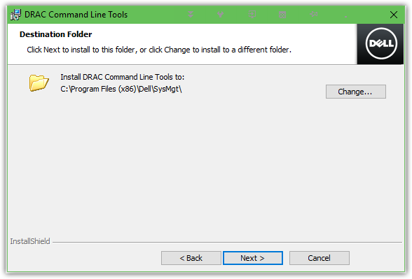

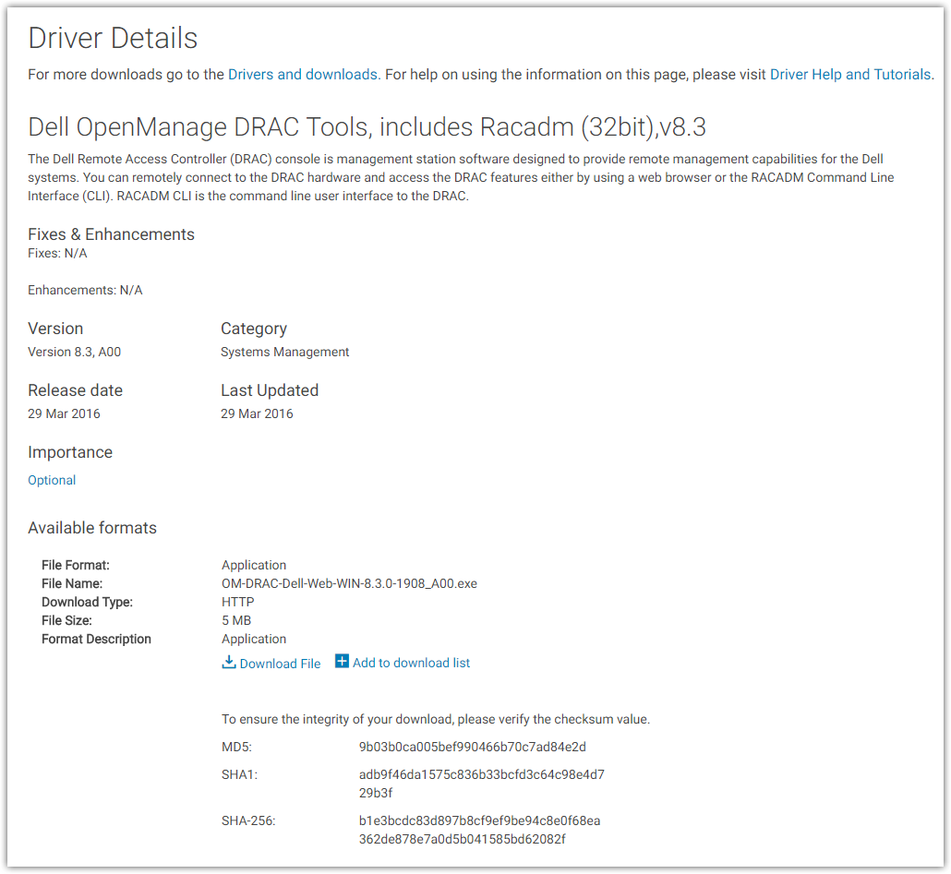

# 20170803
# Using DSU utility to Firmware update.
#

[root@ds-pr-onltraces01p ~]# curl http://repo-linux/tcs-dell-dsu-rhel7.repo.sh | sh
% Total % Received % Xferd Average Speed Time Time Time Current
Dload Upload Total Spent Left Speed
100 342 100 342 0 0 15695 0 --:--:-- --:--:-- --:--:-- 16285
[root@ds-pr-onltraces01p ~]#

[root@ds-pr-onltraces01p ~]# yum install dsucatalog

[root@ds-pr-onltraces01p ~]# yum install dell-system-update

[root@ds-gp-prd-smdw ~]# for var1_host in ds-gp-prd-sdw14 ; do ssh -t ${var1_host} '( echo ; hostname ; dsu )' ; done

ds-gp-prd-sdw14
Dell System Update 1.4.2
Copyright (C) 2014 Dell Proprietary.
Verifying catalog installation ...
Installing catalog from repository ...
Fetching dsucatalog ...
Reading the catalog ...
Fetching invcol_M18HC_LN64_17.06.000.1171_A00 ...
Verifying inventory collector installation ...
Getting System Inventory ...
Determining Applicable Updates ...

|-----------Dell System Updates-----------|
[ ] represents 'not selected'
[*] represents 'selected'
[-] represents 'Component already at repository version (can be selected only if -e option is used)'
Choose: q - Quit without update, c to Commit, <number> - To Select/Deselect, a - Select All, n - Select None

[ ]1 iDRAC
Current Version : 2.30.30.30 Upgrade to : 2.41.40.40

[ ]2 BCM57800 1-Gigabit Ethernet rev 10 (em4)
Current Version : 08.07.25 Upgrade to : 10.00.15

[ ]3 BCM57800 1-Gigabit Ethernet rev 10 (em3)
Current Version : 08.07.25 Upgrade to : 10.00.15

[ ]4 BCM57800 10-Gigabit Ethernet rev 10 (em2)
Current Version : 08.07.25 Upgrade to : 10.00.15

[ ]5 BCM57800 10-Gigabit Ethernet rev 10 (em1)
Current Version : 08.07.25 Upgrade to : 10.00.15

[ ]6 OpenManage | iDRAC Service Module
Current Version : 0 Upgrade to : 2.5

[ ]7 BIOS
Current Version : 2.1.6 Upgrade to : 2.4.3

[-]8 Firmware for - Disk 0 in Backplane 1 of PERC H730P Mini Controller 0
Current Version : DE11 same as : DE11

[ ]9 Dell 32 Bit uEFI Diagnostics, version 4239, 4239A33, 4239.41
Current Version : 4239A33 Upgrade to : 4239A36

[ ]10 OS COLLECTOR 1.1, OSC_1.1, A00
Current Version : OSC_1.1 Downgrade to : 2.1

[ ]11 Firmware for - Disk 20 in Backplane 1 of PERC H730P Adapter Controller 1
Current Version : DL2B Upgrade to : DL2D

[ ]12 PERC H730P Adapter Controller 1 Firmware
Current Version : 25.4.0.0017 Upgrade to : 25.5.2.0001

[ ]13 PERC H730P Mini Controller 0 Firmware
Current Version : 25.4.0.0017 Upgrade to : 25.5.2.0001

[ ]14 13G Backplane Expander FW
Current Version : 3.03 Upgrade to : 3.32

Enter your choice : a

|-----------Dell System Updates-----------|
[ ] represents 'not selected'
[*] represents 'selected'
[-] represents 'Component already at repository version (can be selected only if -e option is used)'
Choose: q - Quit without update, c to Commit, <number> - To Select/Deselect, a - Select All, n - Select None

[*]1 iDRAC
Current Version : 2.30.30.30 Upgrade to : 2.41.40.40

[*]2 BCM57800 1-Gigabit Ethernet rev 10 (em4)
Current Version : 08.07.25 Upgrade to : 10.00.15

[*]3 BCM57800 1-Gigabit Ethernet rev 10 (em3)
Current Version : 08.07.25 Upgrade to : 10.00.15

[*]4 BCM57800 10-Gigabit Ethernet rev 10 (em2)
Current Version : 08.07.25 Upgrade to : 10.00.15

[*]5 BCM57800 10-Gigabit Ethernet rev 10 (em1)
Current Version : 08.07.25 Upgrade to : 10.00.15

[*]6 OpenManage | iDRAC Service Module
Current Version : 0 Upgrade to : 2.5

[*]7 BIOS
Current Version : 2.1.6 Upgrade to : 2.4.3

[-]8 Firmware for - Disk 0 in Backplane 1 of PERC H730P Mini Controller 0
Current Version : DE11 same as : DE11

[*]9 Dell 32 Bit uEFI Diagnostics, version 4239, 4239A33, 4239.41
Current Version : 4239A33 Upgrade to : 4239A36

[*]10 OS COLLECTOR 1.1, OSC_1.1, A00
Current Version : OSC_1.1 Downgrade to : 2.1

[*]11 Firmware for - Disk 20 in Backplane 1 of PERC H730P Adapter Controller 1
Current Version : DL2B Upgrade to : DL2D

[*]12 PERC H730P Adapter Controller 1 Firmware
Current Version : 25.4.0.0017 Upgrade to : 25.5.2.0001

[*]13 PERC H730P Mini Controller 0 Firmware
Current Version : 25.4.0.0017 Upgrade to : 25.5.2.0001

[*]14 13G Backplane Expander FW
Current Version : 3.03 Upgrade to : 3.32

Enter your choice : c
Fetching Systems-Management_Application_DT30R_LN64_2.5_A00 ...
Installing Systems-Management_Application_DT30R_LN64_2.5_A00
Collecting inventory...
.
Running validation...

OpenManage || iDRAC Service Module

No version of this Update Package is currently installed.
Software application name: OpenManage | iDRAC Service Module
Package version: 2.5

Executing update...
WARNING: DO NOT STOP THIS PROCESS OR INSTALL OTHER DELL PRODUCTS WHILE UPDATE IS IN PROGRESS.
THESE ACTIONS MAY CAUSE YOUR SYSTEM TO BECOME UNSTABLE!
.
Update Failed

Systems-Management_Application_DT30R_LN64_2.5_A00 could not be installed
Fetching Diagnostics_Application_NNPW9_LN_4239A36_4239.44 ...
Installing Diagnostics_Application_NNPW9_LN_4239A36_4239.44
Collecting inventory...
...............................................
Running validation...

Dell 32 Bit uEFI Diagnostics, version 4239, 4239A33, 4239.41

The version of this Update Package is newer than the currently installed version.
Software application name: Dell 32 Bit uEFI Diagnostics, version 4239, 4239A33, 4239.41
Package version: 4239A36
Installed version: 4239A33

Executing update...
WARNING: DO NOT STOP THIS PROCESS OR INSTALL OTHER DELL PRODUCTS WHILE UPDATE IS IN PROGRESS.
THESE ACTIONS MAY CAUSE YOUR SYSTEM TO BECOME UNSTABLE!
......................................................................................................................................
The update completed successfully.
Fetching Diagnostics_Application_VX3V5_LN64_2.1_A00 ...
Installing Diagnostics_Application_VX3V5_LN64_2.1_A00
Collecting inventory...
................................................
Running validation...

OS COLLECTOR 1.1, OSC_1.1, A00

The version of this Update Package is older than the currently installed version.
Software application name: OS COLLECTOR 1.1, OSC_1.1, A00
Package version: 2.1
Installed version: OSC_1.1

Executing update...
WARNING: DO NOT STOP THIS PROCESS OR INSTALL OTHER DELL PRODUCTS WHILE UPDATE IS IN PROGRESS.
THESE ACTIONS MAY CAUSE YOUR SYSTEM TO BECOME UNSTABLE!
..............................................................................................................................................
The update completed successfully.
Fetching iDRAC-with-Lifecycle-Controller_Firmware_4950Y_LN_2.41.40.40_A00 ...
Installing iDRAC-with-Lifecycle-Controller_Firmware_4950Y_LN_2.41.40.40_A00
Collecting inventory...
.
Running validation...

iDRAC

The version of this Update Package is newer than the currently installed version.
Software application name: iDRAC
Package version: 2.41.40.40
Installed version: 2.30.30.30

Executing update...
WARNING: DO NOT STOP THIS PROCESS OR INSTALL OTHER DELL PRODUCTS WHILE UPDATE IS IN PROGRESS.
THESE ACTIONS MAY CAUSE YOUR SYSTEM TO BECOME UNSTABLE!
..............................................................................................................................................................................................................................................................................................................................................................................................................................................................................................................
The update completed successfully.
Fetching Network_Firmware_98GPG_LN_10.00.15_A00-00 ...
Installing Network_Firmware_98GPG_LN_10.00.15_A00-00
Collecting inventory...
.
Running validation...

BCM57800 10-Gigabit Ethernet rev 10 (em1)

The version of this Update Package is newer than the currently installed version.
Software application name: BCM57800 10-Gigabit Ethernet rev 10 (em1)
Package version: 10.00.15
Installed version: 08.07.25

BCM57800 10-Gigabit Ethernet rev 10 (em2)

The version of this Update Package is newer than the currently installed version.
Software application name: BCM57800 10-Gigabit Ethernet rev 10 (em2)
Package version: 10.00.15
Installed version: 08.07.25

BCM57800 1-Gigabit Ethernet rev 10 (em3)

The version of this Update Package is newer than the currently installed version.
Software application name: BCM57800 1-Gigabit Ethernet rev 10 (em3)
Package version: 10.00.15
Installed version: 08.07.25

BCM57800 1-Gigabit Ethernet rev 10 (em4)

The version of this Update Package is newer than the currently installed version.
Software application name: BCM57800 1-Gigabit Ethernet rev 10 (em4)
Package version: 10.00.15
Installed version: 08.07.25

Executing update...
WARNING: DO NOT STOP THIS PROCESS OR INSTALL OTHER PRODUCTS WHILE UPDATE IS IN PROGRESS.
THESE ACTIONS MAY CAUSE YOUR SYSTEM TO BECOME UNSTABLE!
...........................................................................................................................................................
The system should be restarted for the update to take effect.
Fetching Serial-ATA_Firmware_KCXYV_LN_DL2D_A00 ...
Installing Serial-ATA_Firmware_KCXYV_LN_DL2D_A00
Collecting inventory...
..
Running validation...

INTEL SSDSC2BA40

The version of this Update Package is newer than the currently installed version.
Software application name: Firmware for - Disk 20 in Backplane 1 of PERC H730P Adapter Controller 1
FQDD: Disk.Bay.20:Enclosure.Internal.1:RAID.Integrated.1-1
Package version: DL2D
Installed version: DL2B

INTEL SSDSC2BA40

The version of this Update Package is newer than the currently installed version.
Software application name: Firmware for - Disk 21 in Backplane 1 of PERC H730P Adapter Controller 1
FQDD: Disk.Bay.21:Enclosure.Internal.1:RAID.Integrated.1-1
Package version: DL2D
Installed version: DL2B

Executing update...
WARNING: DO NOT STOP THIS PROCESS OR INSTALL OTHER PRODUCTS WHILE UPDATE IS IN PROGRESS.
THESE ACTIONS MAY CAUSE YOUR SYSTEM TO BECOME UNSTABLE!
..................................................................................................................................
The update completed successfully.
Fetching SAS-RAID_Firmware_NH55C_LN_25.5.2.0001_A09_02 ...
Installing SAS-RAID_Firmware_NH55C_LN_25.5.2.0001_A09_02
Collecting inventory...
..
Running validation...

PERC H730P Adapter Controller 1

The version of this Update Package is newer than the currently installed version.
Software application name: PERC H730P Adapter Controller 1 Firmware
Package version: 25.5.2.0001
Installed version: 25.4.0.0017

PERC H730P Mini Controller 0

The version of this Update Package is newer than the currently installed version.
Software application name: PERC H730P Mini Controller 0 Firmware
Package version: 25.5.2.0001
Installed version: 25.4.0.0017

Executing update...
WARNING: DO NOT STOP THIS PROCESS OR INSTALL OTHER PRODUCTS WHILE UPDATE IS IN PROGRESS.
THESE ACTIONS MAY CAUSE YOUR SYSTEM TO BECOME UNSTABLE!
...................................................................................................................
The system should be restarted for the update to take effect.
Fetching Firmware_V23C6_LN_3.32_A00-00_03 ...
Installing Firmware_V23C6_LN_3.32_A00-00_03
Collecting inventory...
......................
Running validation...

13G Backplane Expander Firmware

The version of this Update Package is newer than the currently installed version.
Software application name: 13G Backplane Expander Firmware
Package version: 3.32
Installed version: 3.03

Executing update...
WARNING: DO NOT STOP THIS PROCESS OR INSTALL OTHER PRODUCTS WHILE UPDATE IS IN PROGRESS.
THESE ACTIONS MAY CAUSE YOUR SYSTEM TO BECOME UNSTABLE!
........................................................................
The update completed successfully.
Fetching BIOS_6YDCM_LN_2.4.3 ...
Installing BIOS_6YDCM_LN_2.4.3
Collecting inventory...

Running validation...

PowerEdge BIOS

The version of this Update Package is newer than the currently installed version.
Software application name: BIOS
Package version: 2.4.3
Installed version: 2.1.6

Executing update...
WARNING: DO NOT STOP THIS PROCESS OR INSTALL OTHER DELL PRODUCTS WHILE UPDATE IS IN PROGRESS.
THESE ACTIONS MAY CAUSE YOUR SYSTEM TO BECOME UNSTABLE!
.........................................................
The system should be restarted for the update to take effect.
Please reboot the system for update(s) to take effect
Done! Please run 'dsu --inventory' to check the inventory
Exiting DSU!
Connection to ds-gp-prd-sdw14 closed.
[root@ds-gp-prd-smdw ~]#

#
# 20190603
# How to get mac addresses of embedded network cards.
#
[s.belogrud@TCS4357]# ssh tcsbank.ru\\s.belogrud@10.219.109.178 racadm getsysinfo | egrep -ie "Host Name|Service Tag|NIC.*1-1-1|NIC.*1-2-1"
Service Tag = 778V762
Host Name = m1-gp-prod-sdw20
NIC.Integrated.1-1-1 Ethernet = 44:A8:42:2F:AB:C5
NIC.Integrated.1-2-1 Ethernet = 44:A8:42:2F:AB:C7
[s.belogrud@TCS4357]#

[s.belogrud@TCS4357]# ssh tcsbank.ru\\s.belogrud@10.219.109.178
...
/admin1-> racadm get
iDRAC
System
LifeCycleController
BIOS
NIC
STORAGE
FC
/admin1->

/admin1-> racadm get nic.nicconfig
NIC.nicconfig.1 [Key=NIC.Integrated.1-1-1#nicconfig]
NIC.nicconfig.2 [Key=NIC.Integrated.1-2-1#nicconfig]
NIC.nicconfig.3 [Key=NIC.Integrated.1-3-1#nicconfig]
NIC.nicconfig.4 [Key=NIC.Integrated.1-4-1#nicconfig]
/admin1-> racadm get nic.nicconfig.1
[Key=NIC.Integrated.1-1-1#nicconfig]
BannerMessageTimeout=5
BootOptionROM=Enabled
BootRetryCnt=NoRetry
BootStrapType=AutoDetect
HideSetupPrompt=Disabled
LegacyBootProto=PXE
LnkSpeed=10Gbps
#VLanId=1
VLanMode=Disabled
WakeOnLan=Disabled
/admin1->

https://rowty.net/view/84/1/Power-on--off-Dell-server-from-idrac

Power on, off Dell server from idrac
rated 3 times [ 3] [ 0] / comments: 3 / hits: 3155 / 2 yaers ago, fri, mar 3, 2017, 09:32:34
You can use the following commands after ssh to idrac to power off, on, cycle, etc.. your Dell server
# power server off
racadm serveraction powerdown

# power server on
racadm serveraction powerup

# perform server power cycle
racadm serveraction powercycle

# force hard server power reset
racadm serveraction hardreset

# display current power status of server
racadm serveraction powerstatus

#
# 20190821
# Failure on Backplane.
# And only nagios show this failure.
# In iDRAC I see everything is “Green”.
#

[root@vm-vol-nag4-tst objects]# /usr/local/nagios/libexec/check_openmanage -H 10.216.2.32 -C tcspub -P 2c -p
Enclosure 0:0:1 [Backplane] on controller 0 is Failed
Enclosure 1:0:1 [Backplane] on controller 1 is Failed|T0_System_Board_Inlet=23C;42;47 T1_System_Board_Exhaust=36C;70;75 T2_CPU1=55C;85;90 T3_CPU2=51C;85;90 W2_System_Board_Pwr_Consumption=336W;0;0
A0_PS1_Current_1=0.8A;0;0 A1_PS2_Current_2=0.6A;0;0 V26_PS1_Voltage_1=228V;0;0 V27_PS2_Voltage_2=228V;0;0 F0_System_Board_Fan1=6360rpm;0;0 F1_System_Board_Fan2=6240rpm;0;0 F2_System_Board_Fan3=6240
rpm;0;0 F3_System_Board_Fan4=6120rpm;0;0 F4_System_Board_Fan5=6240rpm;0;0 F5_System_Board_Fan6=6240rpm;0;0
[root@vm-vol-nag4-tst objects]#

[root@vm-vol-nag4-tst objects]# /usr/local/nagios/libexec/check_openmanage -H 10.216.2.32 -C tcspub -P 2c -p -d
System: PowerEdge R730xd OMSA version: 9.3.0
ServiceTag: 2FBV762 Plugin version: 3.7.12
BIOS/date: 2.9.1 12/04/2018 Checking mode: SNMPv2c UDP/IPv4
-----------------------------------------------------------------------------
Storage Components
=============================================================================
STATE | ID | MESSAGE TEXT
---------+----------+--------------------------------------------------------
OK | 0 | Controller 0 [PERC H730P Mini] is Ready

...
CRITICAL | 0:0:1 | Enclosure 0:0:1 [Backplane] on controller 0 is Failed
CRITICAL | 1:0:1 | Enclosure 1:0:1 [Backplane] on controller 1 is Failed
-----------------------------------------------------------------------------

[14:30:50 root@m1-gp-prod-sdw32 ~]# omreport storage enclosure
List of Enclosures in the System

Enclosure(s) on Controller PERC H730P Mini (Embedded)

ID : 0:1
Status : Critical
Name : Backplane
State : Failed
Connector : 0
Target ID : Not Applicable
Configuration : Not Applicable
Firmware Version : 3.35
Downstream Firmware Version : Not Applicable
Service Tag : Not Applicable
Express Service Code : Not Applicable
Asset Tag : Not Applicable
Asset Name : Not Applicable
Backplane Part Number : Not Applicable
Split Bus Part Number : Not Applicable
Enclosure Part Number : Not Applicable
SAS Address : 500056B3841934FD
Enclosure Alarm : Not Applicable

Enclosure(s) on Controller PERC H730P Adapter (Slot 3)
ID : 0:1
Status : Critical
Name : Backplane
State : Failed
Connector : 0
Target ID : Not Applicable
Configuration : Not Applicable
Firmware Version : 3.35
Downstream Firmware Version : Not Applicable
Service Tag : Not Applicable
Express Service Code : Not Applicable
Asset Tag : Not Applicable
Asset Name : Not Applicable
Backplane Part Number : Not Applicable
Split Bus Part Number : Not Applicable
Enclosure Part Number : Not Applicable
SAS Address : 500056B3841934FD
Enclosure Alarm : Not Applicable

[14:31:09 root@m1-gp-prod-sdw32 ~]#

#
# But here - there are no problems.
#
[14:16:03 root@m1-gp-prod-sdw32 ~]# omreport chassis
Health

Main System Chassis

SEVERITY : COMPONENT
Ok : Fans
Ok : Intrusion
Ok : Memory
Ok : Power Supplies
Ok : Power Management
Ok : Processors
Ok : Temperatures
Ok : Voltages
Ok : Hardware Log
Ok : Batteries

For further help, type the command followed by -?

[14:16:19 root@m1-gp-prod-sdw32 ~]#

#
# 20190919
# Found problems with raid controller cache battery.
# https://www.dell.com/support/manuals/ru/ru/19/integrated-dell-remote-access-cntrllr-8-with-lifecycle-controller-v2.00.00.00/racadm_idrac_pub-v1/storage?guid=guid-9e3676cb-b71d-420b-8c48-c80add258e03&lang=en-us

#
# To see the latest log messages.
#

[16:04:28 root@m1-gp-prod-sdw33 ~]# racadm storage get batteries -o
Battery.Integrated.1:RAID.Slot.3-1
Name = Battery
DeviceDescription = Battery on RAID Controller in Slot 3
Status = Ok
State = Ready
Battery.Integrated.1:RAID.Integrated.1-1
Name = Battery
DeviceDescription = Battery on Integrated RAID Controller 1
Status = Failed
State = Removed

[16:04:30 root@m1-gp-prod-sdw33 ~]#

[15:55:22 root@m1-gp-prod-sdw33 ~]# racadm getsel | tail -n 20
-------------------------------------------------------------------------------
Record: 109
Date/Time: 09/19/2019 15:45:21
Source: system
Severity: Critical
Description: The PERC2 battery has failed.
-------------------------------------------------------------------------------
Record: 110
Date/Time: 09/19/2019 15:50:24
Source: system
Severity: Ok
Description: The PERC2 battery is operating normally.
-------------------------------------------------------------------------------
Record: 111
Date/Time: 09/19/2019 15:53:20
Source: system
Severity: Critical
Description: The PERC2 battery has failed.
-------------------------------------------------------------------------------

[15:55:39 root@m1-gp-prod-sdw33 ~]#

#
# To see count of messages.
[15:52:24 root@m1-gp-prod-sdw33 ~]# racadm getsel -c 5
Record: 1
Date/Time: 09/18/2019 23:02:01
Source: system
Severity: Ok
Description: Log cleared.
-------------------------------------------------------------------------------
Record: 2
Date/Time: 09/18/2019 23:06:53
Source: system
Severity: Ok
Description: The PERC2 battery is operating normally.
-------------------------------------------------------------------------------
Record: 3
Date/Time: 09/18/2019 23:11:08
Source: system
Severity: Critical
Description: The PERC2 battery has failed.
-------------------------------------------------------------------------------
Record: 4
Date/Time: 09/18/2019 23:17:19
Source: system
Severity: Ok
Description: The PERC2 battery is operating normally.
-------------------------------------------------------------------------------
Record: 5
Date/Time: 09/18/2019 23:17:39
Source: system
Severity: Critical
Description: The PERC2 battery has failed.
-------------------------------------------------------------------------------

[15:53:39 root@m1-gp-prod-sdw33 ~]#

# Here is how looks battery problems.
[16:00:28 root@m1-gp-prod-sdw33 ~]# racadm storage get controllers:RAID.Integrated.1-1
RAID.Integrated.1-1
Status = Ok
DeviceDescription = Integrated RAID Controller 1
RollupStatus = Warning
Name = PERC H730P Mini (Embedded)
FirmwareVersion = 25.5.5.0005
DriverVersion = --NA--
RebuildRate = 30
BgiRate = 30
CheckConsistencyRate = 30
ReconstructRate = 30
PatrolReadRate = 30
PatrolReadMode = Automatic
PatrolReadState = Stopped
CheckConsistencyMode = Normal
LoadBalanceSetting = Auto
CopybackMode = ON
PreservedCache = Not Present
CacheMemorySize = 2048 MB
PersistHotspare = Disabled
KeyID = null
SpindownUnconfiguredDrives = Disabled
SpindownHotspare = Disabled
Timeintervalforspindown = 30 (Minutes)
SecurityStatus = Encryption Capable
EncryptionMode = None
SasAddress = 0x544A8420347BFD00
PciDeviceId = 0x5d
PciSubdeviceId = 0x1f47
PciVendorId = 0x1000
PciSubvendorId = 0x1028
PciBus = 0x2
PciDevice = 0x0
PciFunction = 0x0
BusWidth = Unknown
SlotLength = Unknown
SlotType = Unknown
MaxCapableSpeed = 12.0 Gb/s
LearnMode = Not supported
T10PICapability = Capable
SupportRAID10UnevenSpans = Supported
SupportEnhancedAutoForeignImport = Supported
EnhancedAutoImportForeignConfig = Disabled
SupportControllerBootMode = Supported
ControllerBootMode = Continue Boot On Error
RealtimeConfigurationCapability = Capable
bootVD = Disk.Virtual.0:RAID.Integrated.1-1
CurrentControllerMode = RAID

[16:00:48 root@m1-gp-prod-sdw33 ~]#

[17:20:37 root@m1-gp-prod-sdw33 ~]# lsscsi --long -v 0:2:1:0
[0:2:1:0] disk DELL PERC H730P Mini 4.29 /dev/sdb
state=running queue_depth=256 scsi_level=6 type=0 device_blocked=0 timeout=90
dir: /sys/bus/scsi/devices/0:2:1:0 [/sys/devices/pci0000:00/0000:00:01.0/0000:02:00.0/host0/target0:2:1/0:2:1:0]
[17:21:26 root@m1-gp-prod-sdw33 ~]#

[17:22:51 root@m1-gp-prod-sdw33 ~]# lspci -s 0000:02:00.0
02:00.0 RAID bus controller: LSI Logic / Symbios Logic MegaRAID SAS-3 3108 [Invader] (rev 02)
[17:23:00 root@m1-gp-prod-sdw33 ~]#

#
# 20190925
# Some info how to automate iDRAC configuration changes with Power shell scripting.
#

https://wiki.tcsbank.ru/pages/viewpage.action?pageId=530187136

Для настройки параметров через PS, можно воспользоваться следующим способом:

Устанавливаем модуль через NuGet: Find-Module Posh-SSH | Install-Module
Сохраняем связку логин-пароль в переменную $cred = Get-Credential s.barkov@tcsbank.ru
Подключаемся по SSH: $sshsession = New-SSHSession -ComputerName $h -Credential $cred -Verbose -AcceptKey
Создаем поток, который можем читать/писать: $ssh = $sshsession | New-SSHShellStream
Настраиваем DNS: $ssh.WriteLine("racadm set iDRAC.IPv4.DNS1 10.219.50.4")
$ssh.WriteLine("racadm set iDRAC.IPv4.DNS2 10.219.50.5")
Если нужно прочитать ответ, то $ssh.Read()
Закрываем SSH сессию: $sshsession | Remove-SSHSession
Если хотим заскриптовать, то можно сделать так:

Read-host -assecurestring | convertfrom-securestring | out-file 'C:\tasks\dell\p.pwd'

И в скрипте:

$password = get-content C:\tasks\dell\p.pwd | convertto-securestring

$cred = new-object -typename System.Management.Automation.PSCredential -argumentlist "s.barkov@tcsbank.ru",$password

param ($h)

if ($h){

$password = get-content C:\tasks\dell\p.pwd | convertto-securestring

$cred = new-object -typename System.Management.Automation.PSCredential -argumentlist "s.barkov@tcsbank.ru",$password

#$cred = Get-Credential s_barkov@tcsbank.ru
$sshsession = New-SSHSession -ComputerName $h -Credential $cred -Verbose -AcceptKey
start-sleep 3

$ssh = $sshsession | New-SSHShellStream
start-sleep 3

$ssh.WriteLine("racadm set iDRAC.IPv4.DNS1 10.219.50.4")
start-sleep 5

$ssh.Read()
start-sleep 5

$ssh.WriteLine("racadm set iDRAC.IPv4.DNS2 10.219.50.5")
start-sleep 5

$ssh.Read()
start-sleep 5

$sshsession | Remove-SSHSession
}
Вызов: скрипт.ps1 Z8RHXJ2.mgmt.tcsbank.ru

#
# https://wiki.tcsbank.ru/pages/viewpage.action?pageId=526489297
#

#
# http://fibrevillage.com/storage/605-how-to-find-hard-drive-model-and-serial-number-on-linux
#
# scsi_id
# Use scsi_id command to querys a SCSI device via the SCSI INQUIRY vital product data (VPD) page 0x80 or 0x83 and uses the resulting data to generate a value that is unique across all SCSI devices that properly support page 0x80 or page 0x83.
#

Belogrud Sergey Vladimirovich
Если известен серийный номер проблемного диска, как понять к какому разделу файловой системы он относится?

Нажмите здесь для раскрытия...
Относительно быстрый метод на примере сервера у которого есть диски непосредственно смонтированные в файловую систему и есть диски объединённые в raid и уже этот логический диск смонтирован в файловую систему.

Блочные устройства /dev/sg0, /dev/sg1 - это логическое объединение наборов физических дисков в raid-массив.
Блочные устройства /dev/sg2 - /dev/sg11 - это физические диски смонтированные в файловую систему, каждый в свой каталог.

[root@ds-gp-prd-bkp1 ~]# lsscsi -g
[0:0:2:0] disk SEAGATE ST8000NM0075 PS26 /dev/sdc /dev/sg2
[0:0:3:0] disk SEAGATE ST8000NM0075 PS26 /dev/sdd /dev/sg3
[0:0:4:0] disk HGST HUS728T8TAL5200 RS01 /dev/sde /dev/sg4
[0:0:5:0] disk SEAGATE ST8000NM0075 PS26 /dev/sdf /dev/sg5
[0:0:6:0] disk SEAGATE ST8000NM0075 PS26 /dev/sdg /dev/sg6
[0:0:7:0] disk SEAGATE ST8000NM0075 PS26 /dev/sdh /dev/sg7
[0:0:8:0] disk SEAGATE ST8000NM0075 PS26 /dev/sdi /dev/sg8
[0:0:9:0] disk SEAGATE ST8000NM0075 PS26 /dev/sdj /dev/sg9
[0:0:10:0] disk SEAGATE ST8000NM0075 PS26 /dev/sdk /dev/sg10
[0:0:11:0] disk SEAGATE ST8000NM0075 PS26 /dev/sdl /dev/sg11
[0:2:0:0] disk DELL PERC H730P Mini 4.29 /dev/sda /dev/sg0
[0:2:2:0] disk DELL PERC H730P Mini 4.29 /dev/sdb /dev/sg1
[root@ds-gp-prd-bkp1 ~]#
Посмотреть серийные номера дисков, непосредственно смонтированных в файловую систему можно так.
Но эта команда не покажет серийные номера дисков, объединённых в raid-массив. Это блочные устройства /dev/sg0, /dev/sg1.

[root@ds-gp-prd-bkp1 ~]# for var1 in {0..11} ; do echo -e "\nCount: ${var1}: /dev/sg${var1}" ; scsi_id -g -p 0x80 /dev/sg${var1} ; done

Count: 0: /dev/sg0
SDELL PERC H730P Mini00ab3758133602ad1f0068967da06d86

Count: 1: /dev/sg1
SDELL PERC H730P Mini00b109aa0af1e367200068967da06d86

Count: 2: /dev/sg2
SSEAGATE ST8000NM0075 ZA13F1GL

Count: 3: /dev/sg3
SSEAGATE ST8000NM0075 ZA147348

Count: 4: /dev/sg4
SHGST HUS728T8TAL5200VAJ2XV5L

Count: 5: /dev/sg5
SSEAGATE ST8000NM0075 ZA13K0Z0

Count: 6: /dev/sg6
SSEAGATE ST8000NM0075 ZA13JZV9

Count: 7: /dev/sg7
SSEAGATE ST8000NM0075 ZA145HXV

Count: 8: /dev/sg8
SSEAGATE ST8000NM0075 ZA13KMVH

Count: 9: /dev/sg9
SSEAGATE ST8000NM0075 ZA14DT6T

Count: 10: /dev/sg10
SSEAGATE ST8000NM0075 ZA145GQJ

Count: 11: /dev/sg11
SSEAGATE ST8000NM0075 ZA13KLRH
[root@ds-gp-prd-bkp1 ~]#
Пусть для примера серийный номер диска находится среди найденных - допустим это "ZA145HXV".
Здесь, просто так для примера, использованы два способа показать серийный номер диска по известному идентификатору диска. Утилитой scsi_id или smartctl.

[root@ds-gp-prd-bkp1 ~]# scsi_id -g -p 0x80 /dev/sg7
SSEAGATE ST8000NM0075 ZA145HXV
[root@ds-gp-prd-bkp1 ~]#

[root@ds-gp-prd-bkp1 ~]# smartctl -a /dev/sg7 | grep -e "Serial number:" -e "Device type:" -e "Transport protocol:"
Serial number: ZA145HXV
Device type: disk
Transport protocol: SAS
[root@ds-gp-prd-bkp1 ~]#
Теперь по известной идентификации блочного устройства: "/dev/sg7" и выводу команды "lsscsi -g" можно - сопоставляем, что /dev/sg7 это /dev/sdh.
В файловой системе linux искомое блочное устройство определяется, как /dev/sdh.

С помощью следующей команды можно понять в какой каталог смонтировано блочное устройство /dev/sdh - это /data06.

[root@ds-gp-prd-bkp1 ~]# lsblk -o NAME,TYPE,MOUNTPOINT,FSTYPE,SIZE /dev/sdh
NAME TYPE MOUNTPOINT FSTYPE SIZE
sdh disk /data06 ext4 7.3T
[root@ds-gp-prd-bkp1 ~]#

Для случая, когда требуется посмотреть серийные номера дисков, логически объединённых в raid-массив.
Используется утилита smartctl для идентификатора блочного устройства /dev/sg0 (аналогично и для /dev/sg1). Количество индексов для дисков в этой утилите берётся с запасом, чтобы точно быть уверенным, что собрана информация обо всех дисках объединённых в данный raid-массив. Для последних не использующихся индексах - информация о диске будет пустой - диск отсутствует.

[root@ds-gp-prd-bkp1 ~]# for var1 in {0..20} ; do echo -e "\nCount: ${var1}" ; smartctl -a -d megaraid,${var1} /dev/sg0 | grep -e "Serial number:" -e "Device type:" -e "Transport protocol:" ; done

Count: 0
Serial number: X6J0A03PT2XD
Device type: disk
Transport protocol: SAS

Count: 1
Serial number: X6J0A03QT2XD
Device type: disk
Transport protocol: SAS

Count: 2
Serial number: ZA13F1GL
Device type: disk
Transport protocol: SAS

Count: 3
Serial number: ZA147348
Device type: disk
Transport protocol: SAS

Count: 4
Serial number: VAJ2XV5L
Device type: disk
Transport protocol: SAS

Count: 5
Serial number: ZA13K0Z0
Device type: disk
Transport protocol: SAS

Count: 6
Serial number: ZA13JZV9
Device type: disk
Transport protocol: SAS

Count: 7
Serial number: ZA145HXV
Device type: disk
Transport protocol: SAS

Count: 8
Serial number: ZA13KMVH
Device type: disk
Transport protocol: SAS

Count: 9
Serial number: ZA14DT6T
Device type: disk
Transport protocol: SAS

Count: 10
Serial number: ZA145GQJ
Device type: disk
Transport protocol: SAS

Count: 11
Serial number: ZA13KLRH
Device type: disk
Transport protocol: SAS

Count: 12
Serial number: S422JYQ8
Device type: disk
Transport protocol: SAS

Count: 13
Serial number: S422L95K
Device type: disk
Transport protocol: SAS

Count: 14

Count: 15

Count: 16

Count: 17

Count: 18

Count: 19

Count: 20
[root@ds-gp-prd-bkp1 ~]#
И, как и ранее, с помощью следующей команды можно понять какие каталоги размещены на дисках объединённых логически в raid-массив устройстве /dev/sda.

[root@ds-gp-prd-bkp1 ~]# lsblk -o NAME,TYPE,MOUNTPOINT,FSTYPE,SIZE /dev/sda
NAME TYPE MOUNTPOINT FSTYPE SIZE
sda disk 278.9G
├─sda1 part vfat 500M
├─sda2 part vfat 40M
├─sda3 part vfat 2G
├─sda4 part /boot ext2 500M
└─sda5 part LVM2_member 275.9G
├─vg_dsgpprdbkp1-lv_root (dm-0) lvm / ext4 50G
├─vg_dsgpprdbkp1-lv_swap (dm-1) lvm [SWAP] swap 4G
└─vg_dsgpprdbkp1-lv_opt (dm-2) lvm /opt xfs 221.9G
[root@ds-gp-prd-bkp1 ~]#

